Assignment 7
PNR: 260740150018
Name: PRATIK SUNIL ABHANG
Question:
Create a Student class with the following attributes: name, age, and student_id.
The constructor should initialize these attributes.
Add a method display_info() that prints the student's details in a user-friendly format.
Add a method is_eligible_to_vote() that returns True if the student's age is 18 or older, and False otherwise.
Create a student object and test all the methods.
Program
class Student:
def __init__(self, name, age, student_id):
self.name = name
self.age = age
self.student_id = student_id
def display_info(self):
print("\nStudent Details")
print("Name:", self.name)
print("Age:", self.age)
print("Student ID:", self.student_id)
def is_eligible_to_vote(self):
return self.age >= 18
name = input("Enter name: ")
age = int(input("Enter age: "))
student_id = input("Enter student ID: ")
student = Student(name, age, student_id)
student.display_info()
print("Eligible to vote:", student.is_eligible_to_vote())

Input and Output
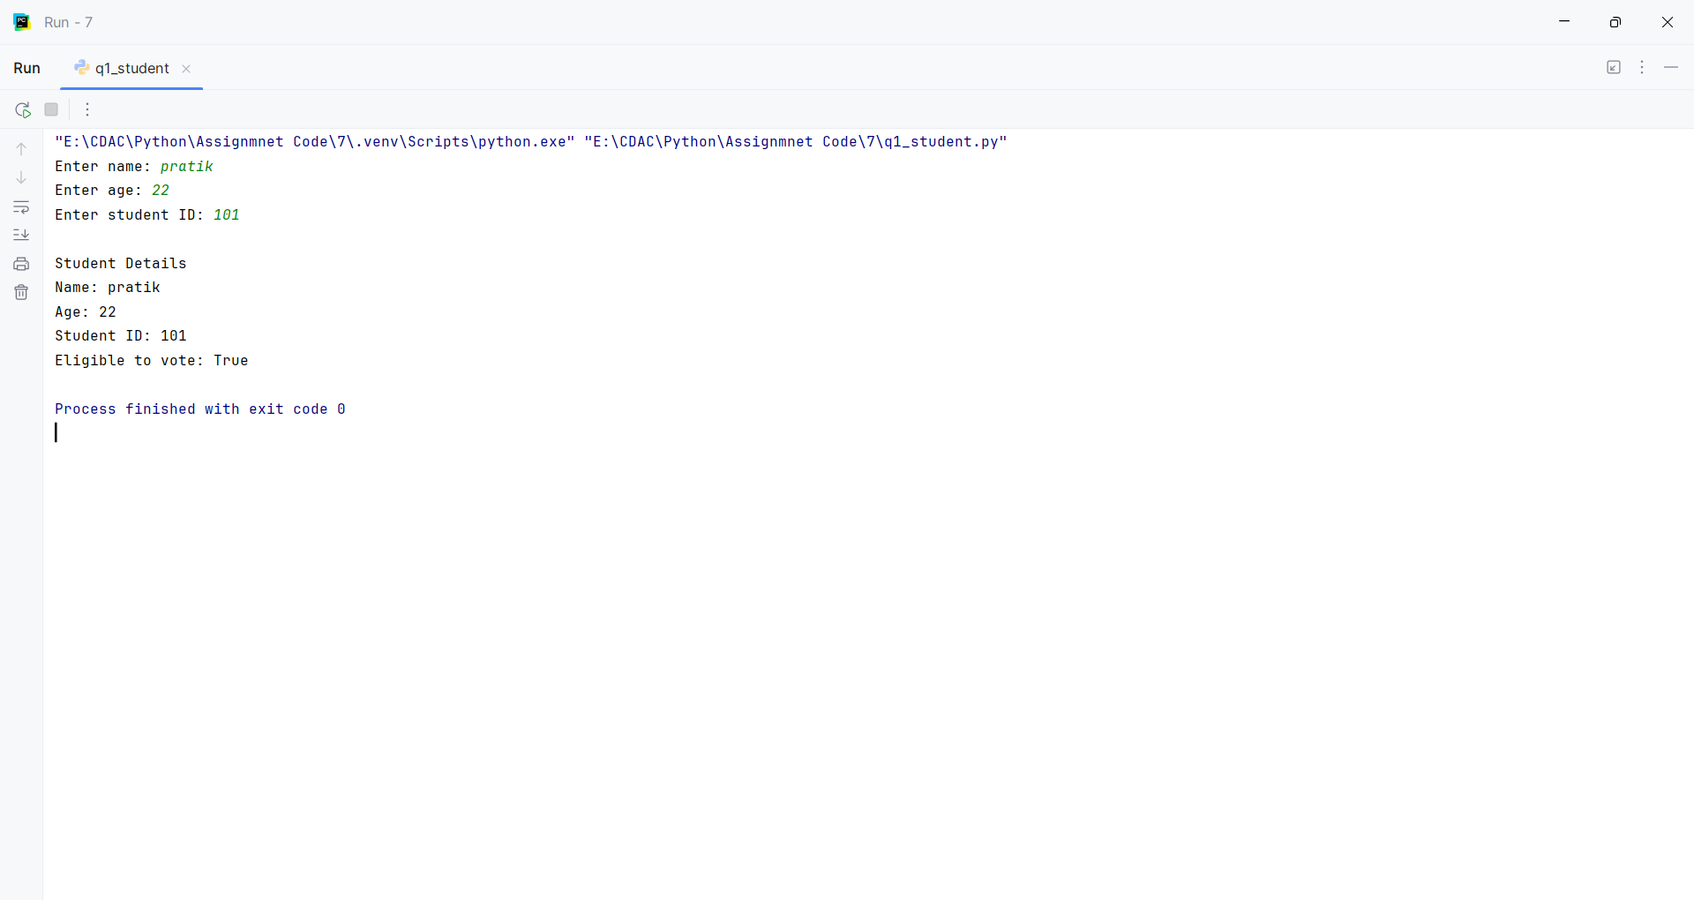
Question:
Create a base class Vehicle with attributes: make, model, and year. The constructor should initialize these.
Add a method display_info() that prints the basic vehicle information.
Create a child class Car that inherits from Vehicle.
The Car class should have an additional attribute num_doors. The constructor should take make, model, year, and num_doors.
Override the display_info() method in the Car class to also include the number of doors.
Create instances of both Vehicle and Car to demonstrate inheritance and method overriding.
Program
class Vehicle:
def __init__(self, make, model, year):
self.make = make
self.model = model
self.year = year
def display_info(self):
print("Vehicle:", self.year, self.make, self.model)
class Car(Vehicle):
def __init__(self, make, model, year, num_doors):
super().__init__(make, model, year)
self.num_doors = num_doors
def display_info(self):
print("Car:", self.year, self.make, self.model)
print("Number of doors:", self.num_doors)
vehicle = Vehicle("Volkswagen", "Virtus", 2024)
car = Car("BMW", "X7", 2024, 5)
vehicle.display_info()
car.display_info()

Input and Output
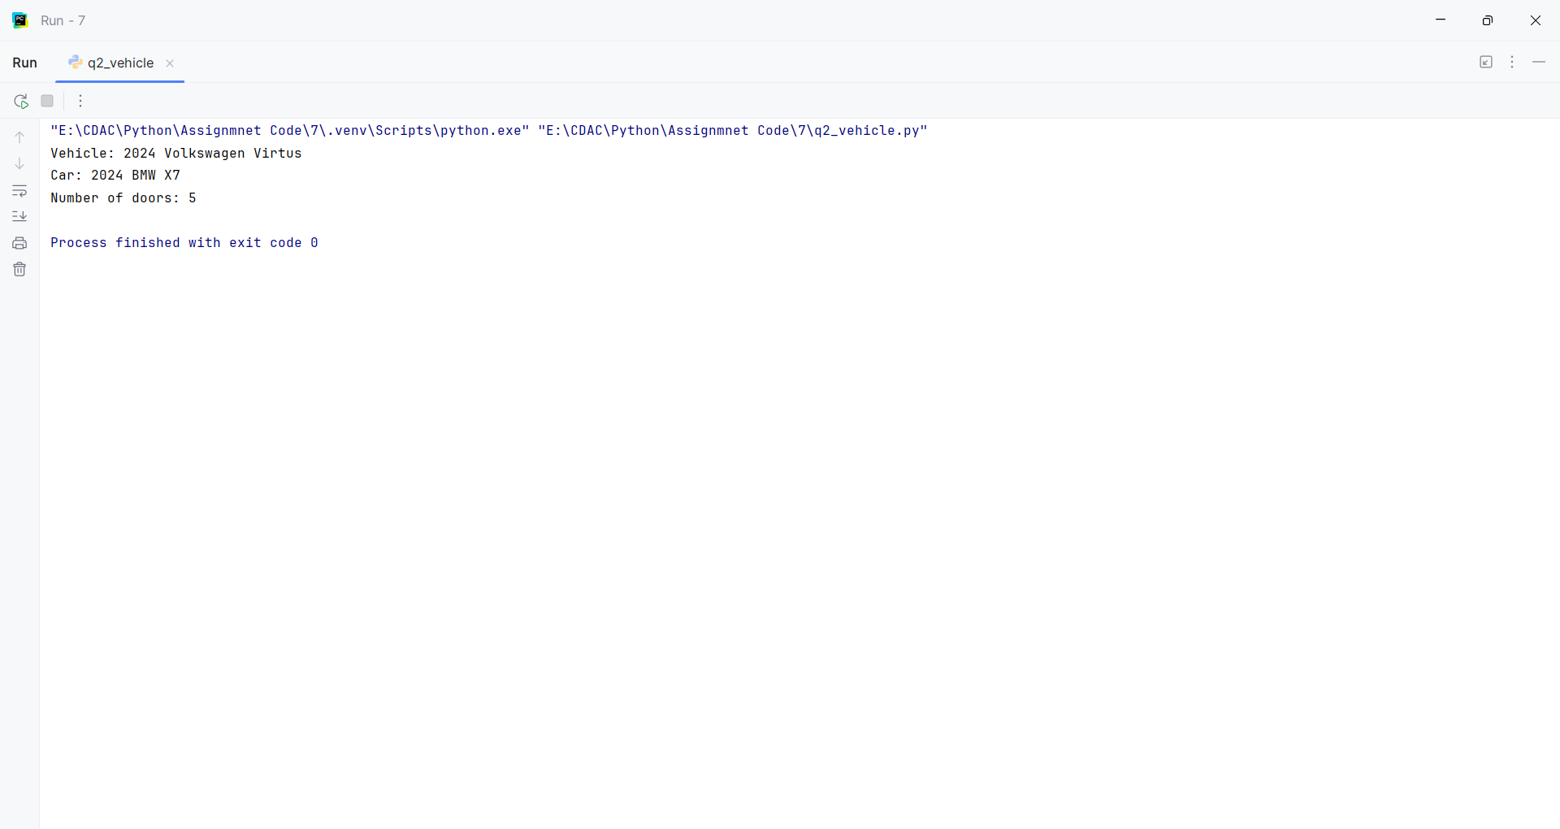
Question:
Employee Management System:
Create a base class Employee with attributes name, employee_id, and salary.
Create a derived class Manager that inherits from Employee and has an additional attribute for a list of employees they manage.
Add methods to both classes, such as a method in Manager to add an employee to their managed list.
Program
class Employee:
def __init__(self, name, employee_id, salary):
self.name = name
self.employee_id = employee_id
self.salary = salary
def display_info(self):
print("Name:", self.name)
print("Employee ID:", self.employee_id)
print("Salary:", self.salary)
class Manager(Employee):
def __init__(self, name, employee_id, salary):
super().__init__(name, employee_id, salary)
self.employees = []
def add_employee(self, employee):
self.employees.append(employee)
def display_employees(self):
print("\nEmployees Managed:")
for employee in self.employees:
print(employee.name)
employee1 = Employee("Rahul", "E101", 30000)
employee2 = Employee("Priya", "E102", 35000)
manager = Manager("Pratik", "M101", 50000)
manager.add_employee(employee1)
manager.add_employee(employee2)
manager.display_info()
manager.display_employees()

Input and Output
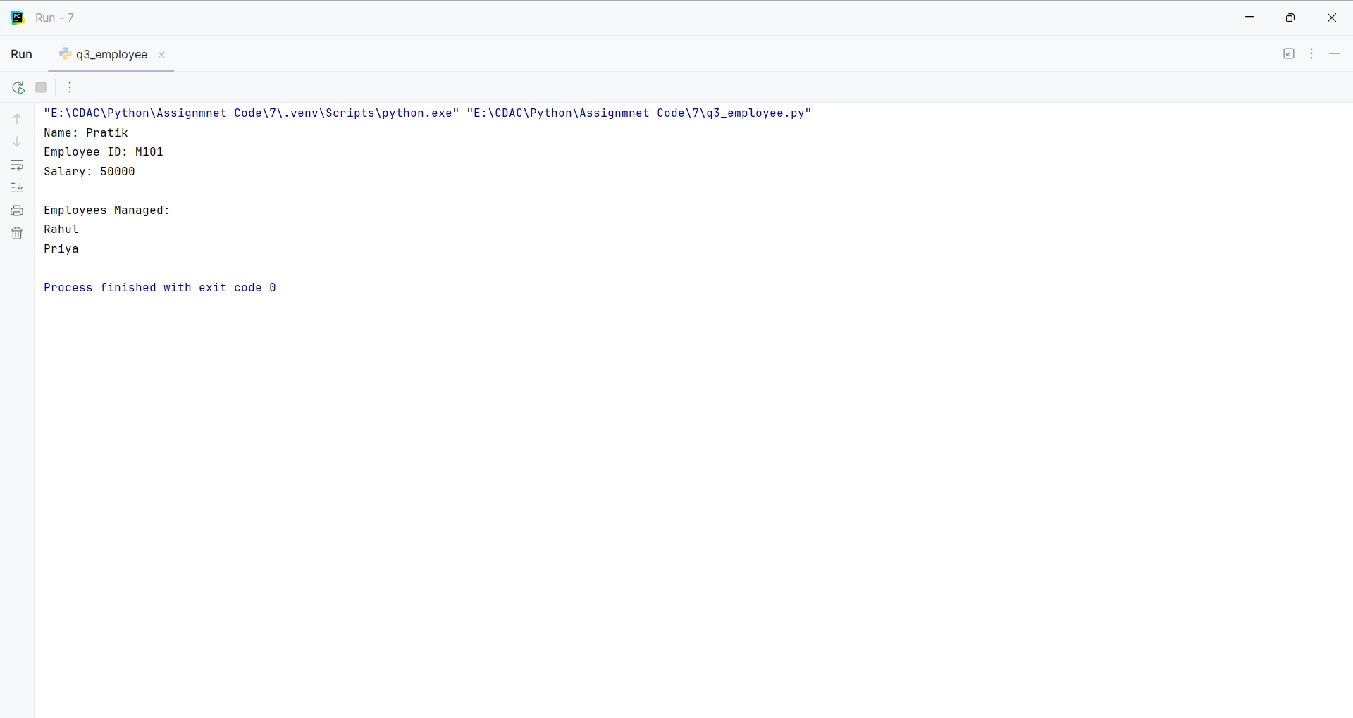
Question:
Library Management System:
Create a Book class with attributes like title, author, and is_available.
Create a Library class that has a list of Book objects.
Add methods to the Library class to:
add_book(book): Adds a new book to the library's collection.
borrow_book(title): Finds a book by title and changes its availability status.
return_book(title): Changes a book's availability status back to available.
display_available_books(): Prints the titles and authors of all available books.
Program
class Book:
def __init__(self, title, author, is_available=True):
self.title = title
self.author = author
self.is_available = is_available
class Library:
def __init__(self):
self.books = []
def add_book(self, book):
self.books.append(book)
def borrow_book(self, title):
for book in self.books:
if book.title == title and book.is_available:
book.is_available = False
print("Book borrowed successfully.")
return
print("Book is not available.")
def return_book(self, title):
for book in self.books:
if book.title == title:
book.is_available = True
print("Book returned successfully.")
return
print("Book not found.")
def display_available_books(self):
print("\nAvailable Books:")
for book in self.books:
if book.is_available:
print(book.title, "-", book.author)
book1 = Book("Python Programming", "Guido van Rossum")
book2 = Book("The Alchemist", "Paulo Coelho")
library = Library()
library.add_book(book1)
library.add_book(book2)
library.display_available_books()
library.borrow_book("Python Programming")
library.display_available_books()
library.return_book("Python Programming")
library.display_available_books()

Input and Output
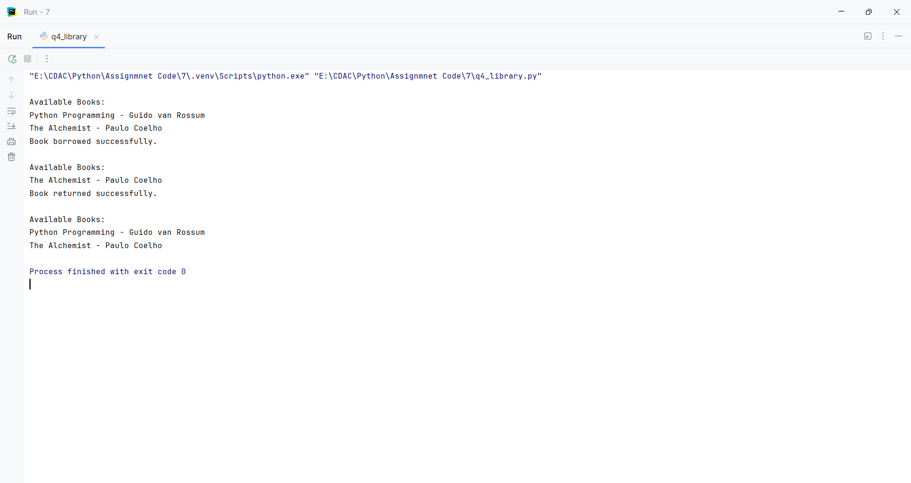
Question:
Write a Python function is_valid_phone(text) that takes a string and returns True if it is a valid 10-digit phone number, and False otherwise. A valid phone number should consist of exactly 10 digits.
Program
import re
def is_valid_phone(text):
return bool(re.fullmatch(r"\d{10}", text))
text = input("Enter a phone number: ")
print(is_valid_phone(text))

Input and Output
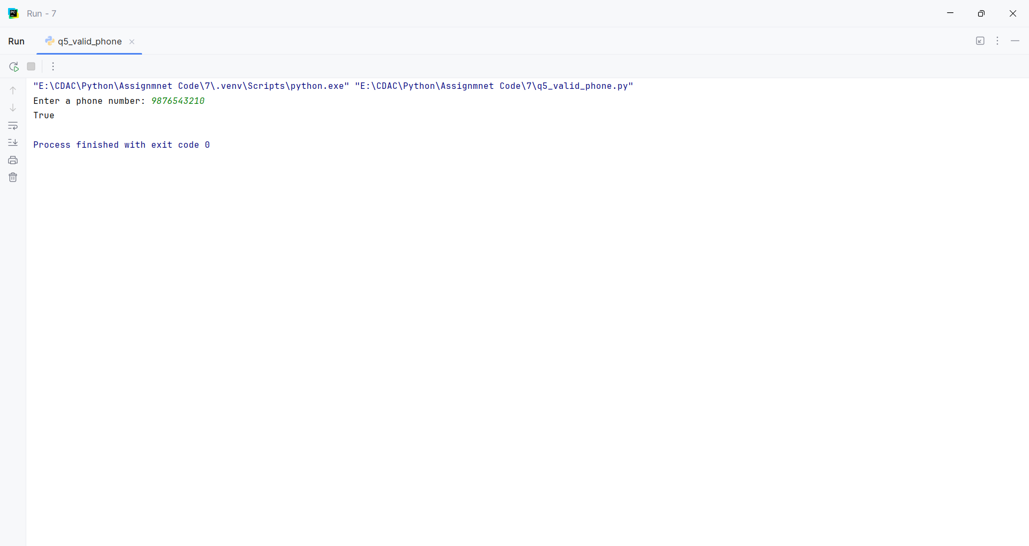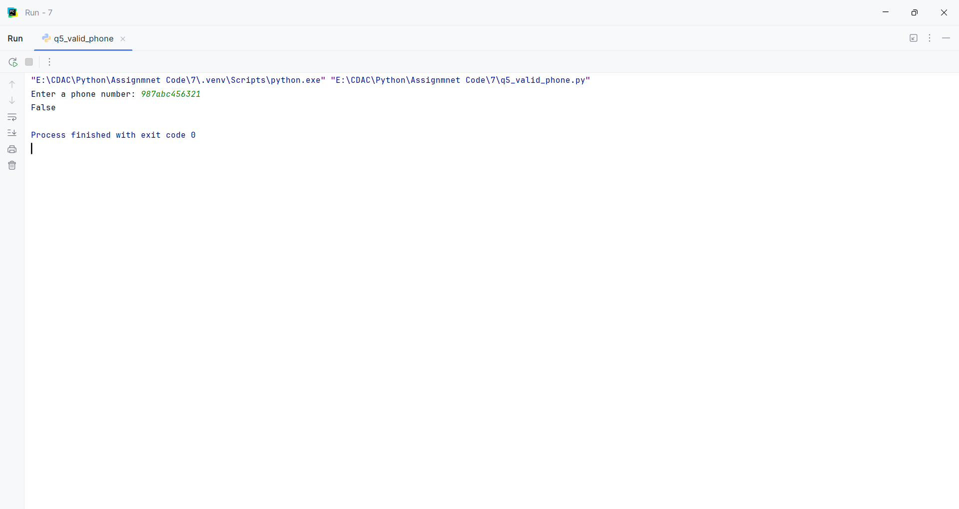
Question:
Write a Python program to find all words in a string that start with the letter 'p' (case-insensitive) and are at least 3 characters long.
Program
import re
text = "Peter Piper picked a peck of pickled peppers"
words = re.findall(r"\b[pP]\w{2,}\b", text)
print(words)

Input and Output
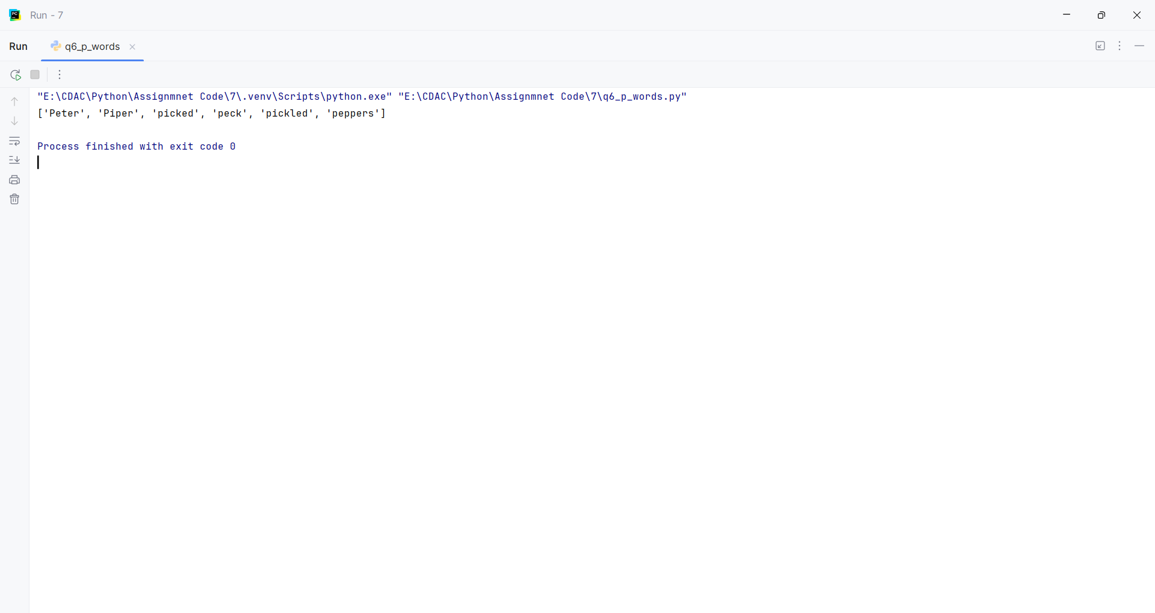
Question:
Write a Python function find_dates(text) to find the first occurrence of a date in the format MM-DD-YYYY and prints the full match.
Program
import re
def find_dates(text="Today is 10-25-2023 and tomorrow is 11-01-2023."):
print("Text:", text)
match = re.search(r"\b\d{2}-\d{2}-\d{4}\b", text)
if match:
print("First date:", match.group())
else:
print("No date found.")
find_dates()

Input and Output
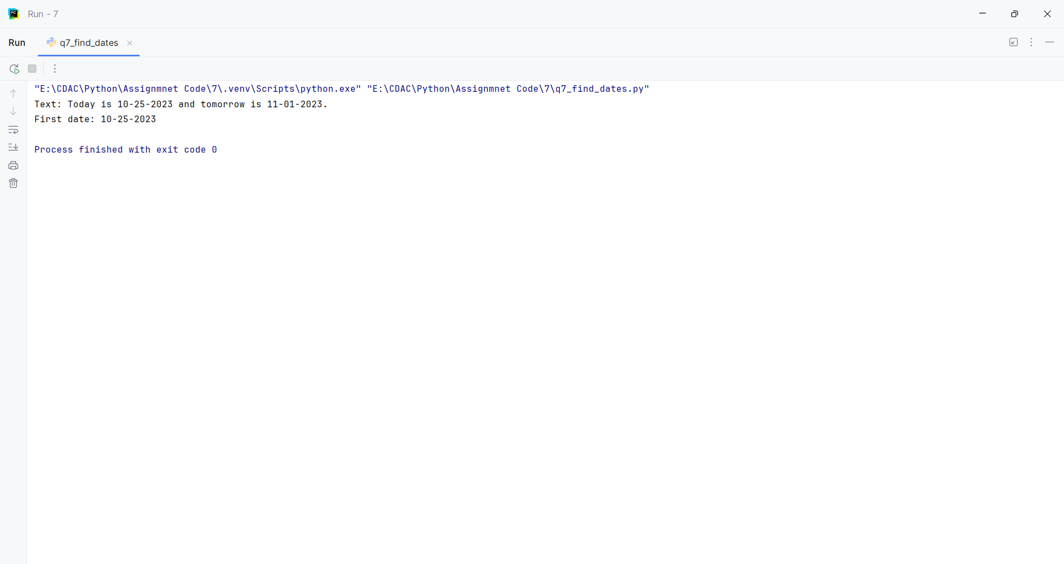
Question:
Write a Python function is_strong_password(password) that uses regex to check if a password meets the following criteria:
At least 8 characters long.
Contains at least one uppercase letter.
Contains at least one lowercase letter.
Contains at least one digit.
Contains at least one special character (e.g., !, @, #, $, %, ^, &, *).
Program
import re
def is_strong_password(password):
pattern = r"^(?=.*[A-Z])(?=.*[a-z])(?=.*\d)(?=.*[!@#$%^&*]).{8,}$"
return bool(re.fullmatch(pattern, password))
password = input("Enter a password: ")
print(is_strong_password(password))

Input and Output
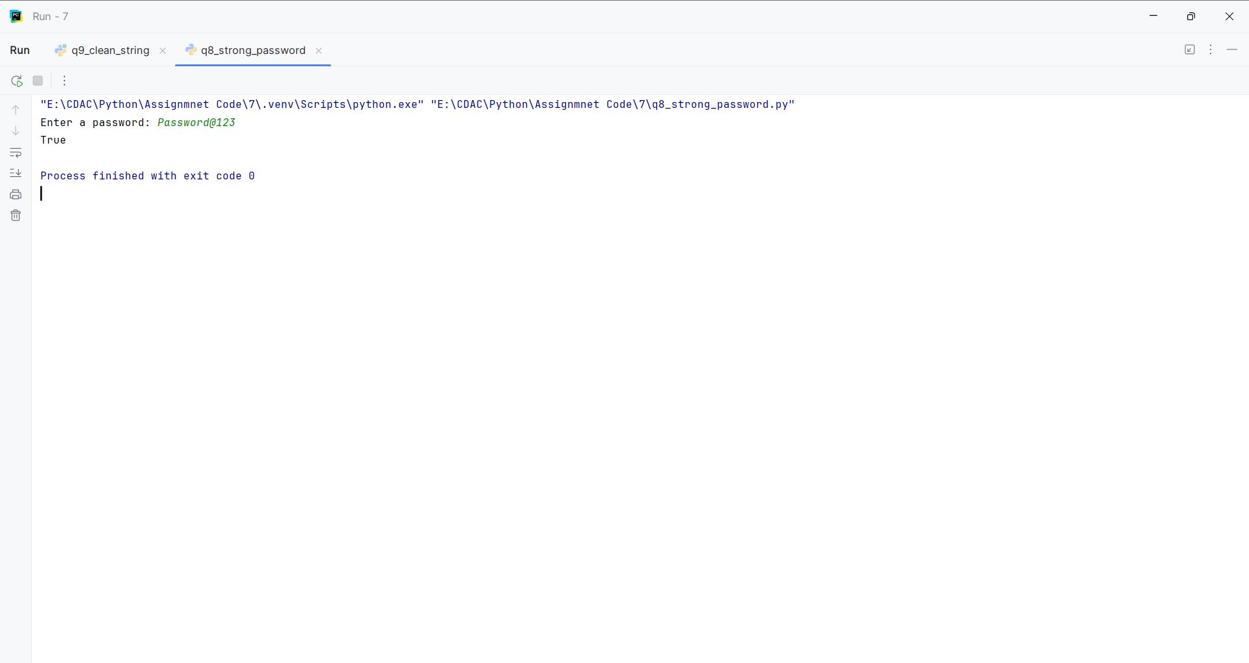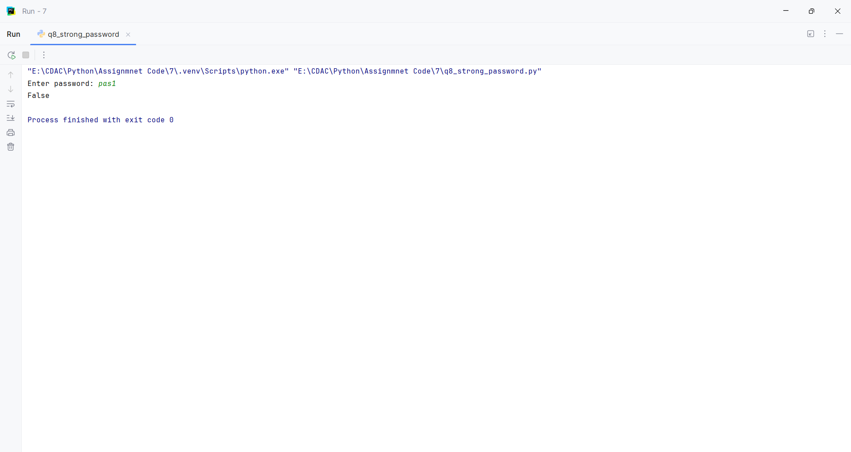
Question:
Write a Python function clean_string(text) that takes a string and performs the following cleaning tasks using regex:
Replace multiple spaces with a single space.
Remove leading and trailing whitespace.
Capitalize the first letter of each sentence.
Program
import re
def clean_string(text=" hello world. how are you? i am fine! "):
text = re.sub(r"\s+", " ", text).strip()
return re.sub(r"(^|[.!?]\s+)([a-z])",
lambda m: m.group(1) + m.group(2).upper(), text)
print("Default:", clean_string())
text = input("Enter a string: ")
print("Cleaned:", clean_string(text))

Input and Output
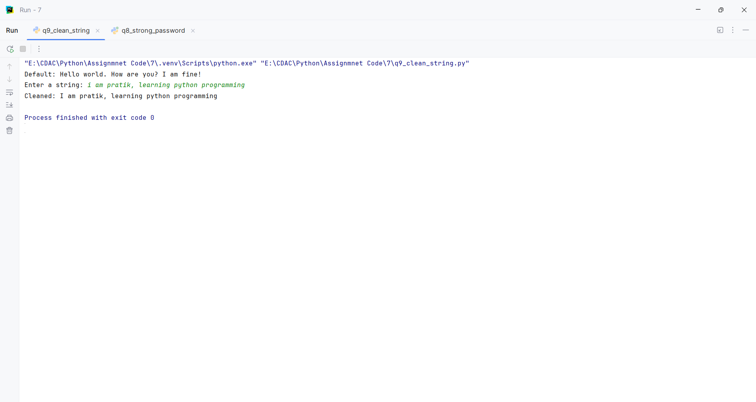
Question:
Write a Python program that takes a string and replace all punctuation marks (e.g., ,, ., !, ?) with an empty string.
Program
import re
def remove_punctuation(text="Hello, World! How are you?"):
return re.sub(r"[^\w\s]", "", text)
print("Default:", remove_punctuation())
text = input("Enter a string: ")
print("Result:", remove_punctuation(text))

Input and Output
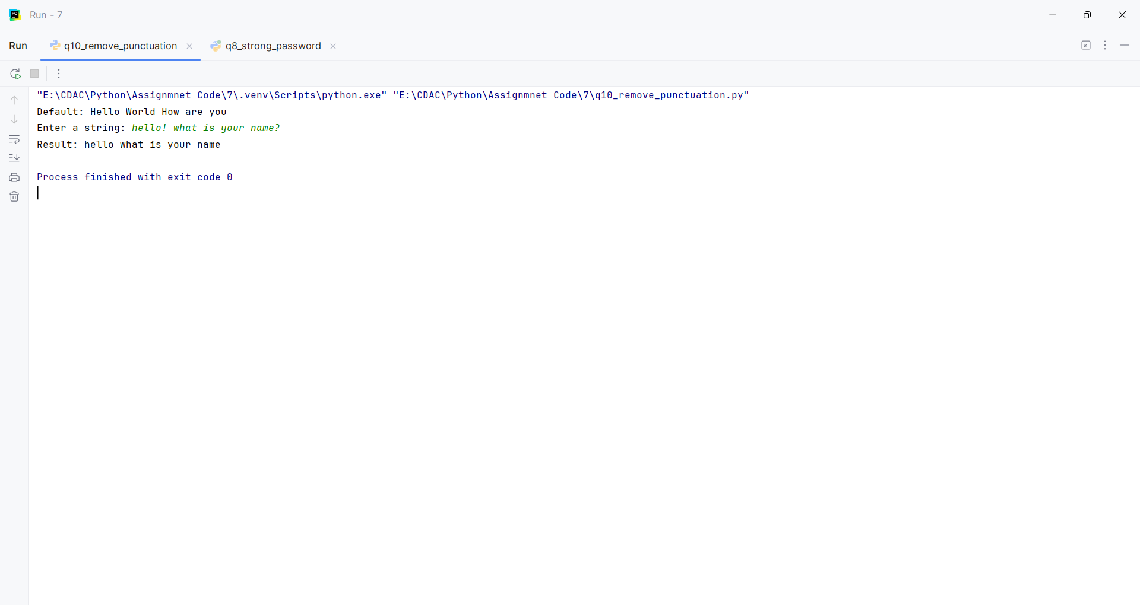
Question:
Read and Print a File:
Create a text file named data.txt with a few lines of text.
Write a Python script that opens data.txt in read mode, reads the entire content, and prints it to the console.
Make sure to use a with statement to handle the file automatically.
Program
def create_data_file():
with open("data.txt", "w") as file:
file.write("Python programming\nFile handling\nEnd of file")
def read_and_print_file():
with open("data.txt", "r") as file:
print(file.read())
create_data_file()
read_and_print_file()

Input and Output
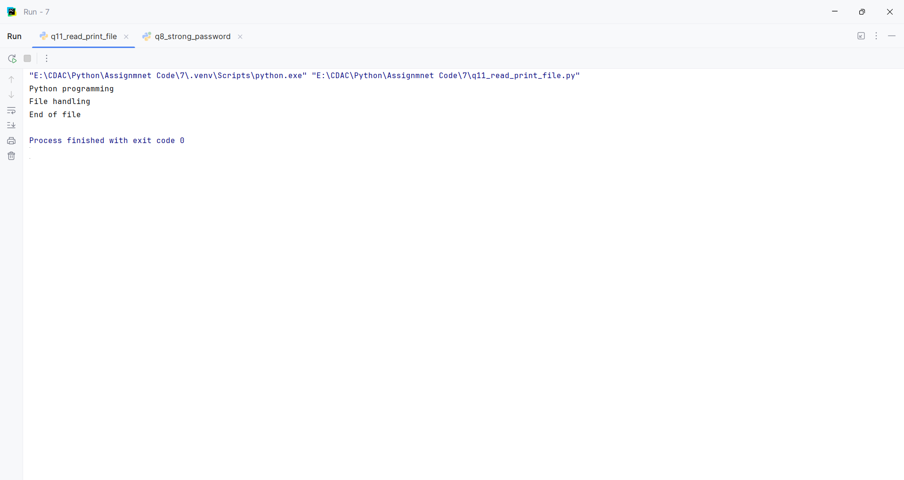
Question:
Count Lines in a File:
Use the data.txt file from the previous question.
Write a Python program that counts the number of lines in the file and prints the total count.
Program
def count_lines(filename="data.txt"):
with open(filename, "r") as file:
return sum(1 for _ in file)
filename = input("Enter file name: ")
print("Total lines:", count_lines(filename))

Input and Output
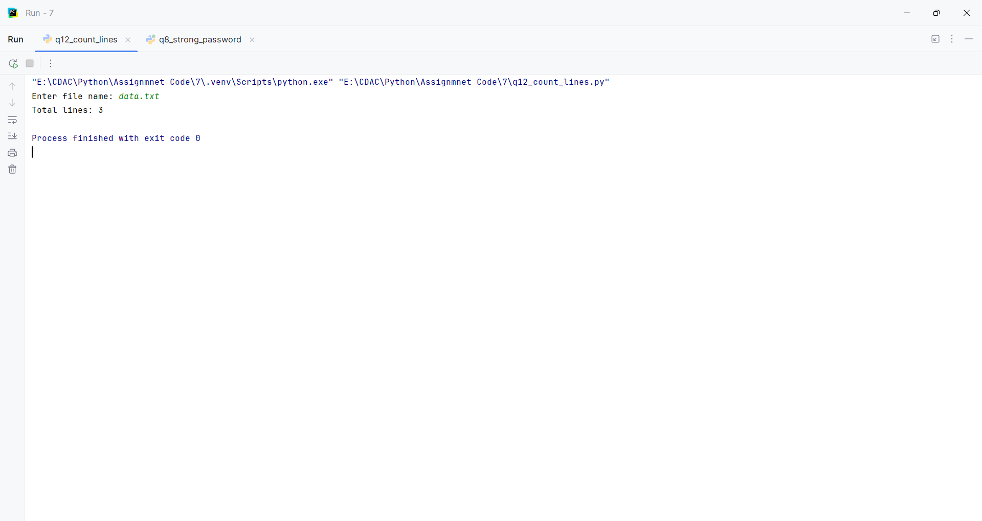
Question:
Append to a File:
Create a file named log.txt.
Write a Python program that prompts the user to enter a log message.
The program should then append this message, along with a timestamp, to the end of log.txt on a new line.
Program
from datetime import datetime
def append_log(message):
timestamp = datetime.now().strftime("%Y-%m-%d %H:%M:%S")
with open("log.txt", "a") as file:
file.write(f"[{timestamp}] {message}\n")
print("Log message appended.")
message = input("Enter a log message: ")
append_log(message)

Input and Output
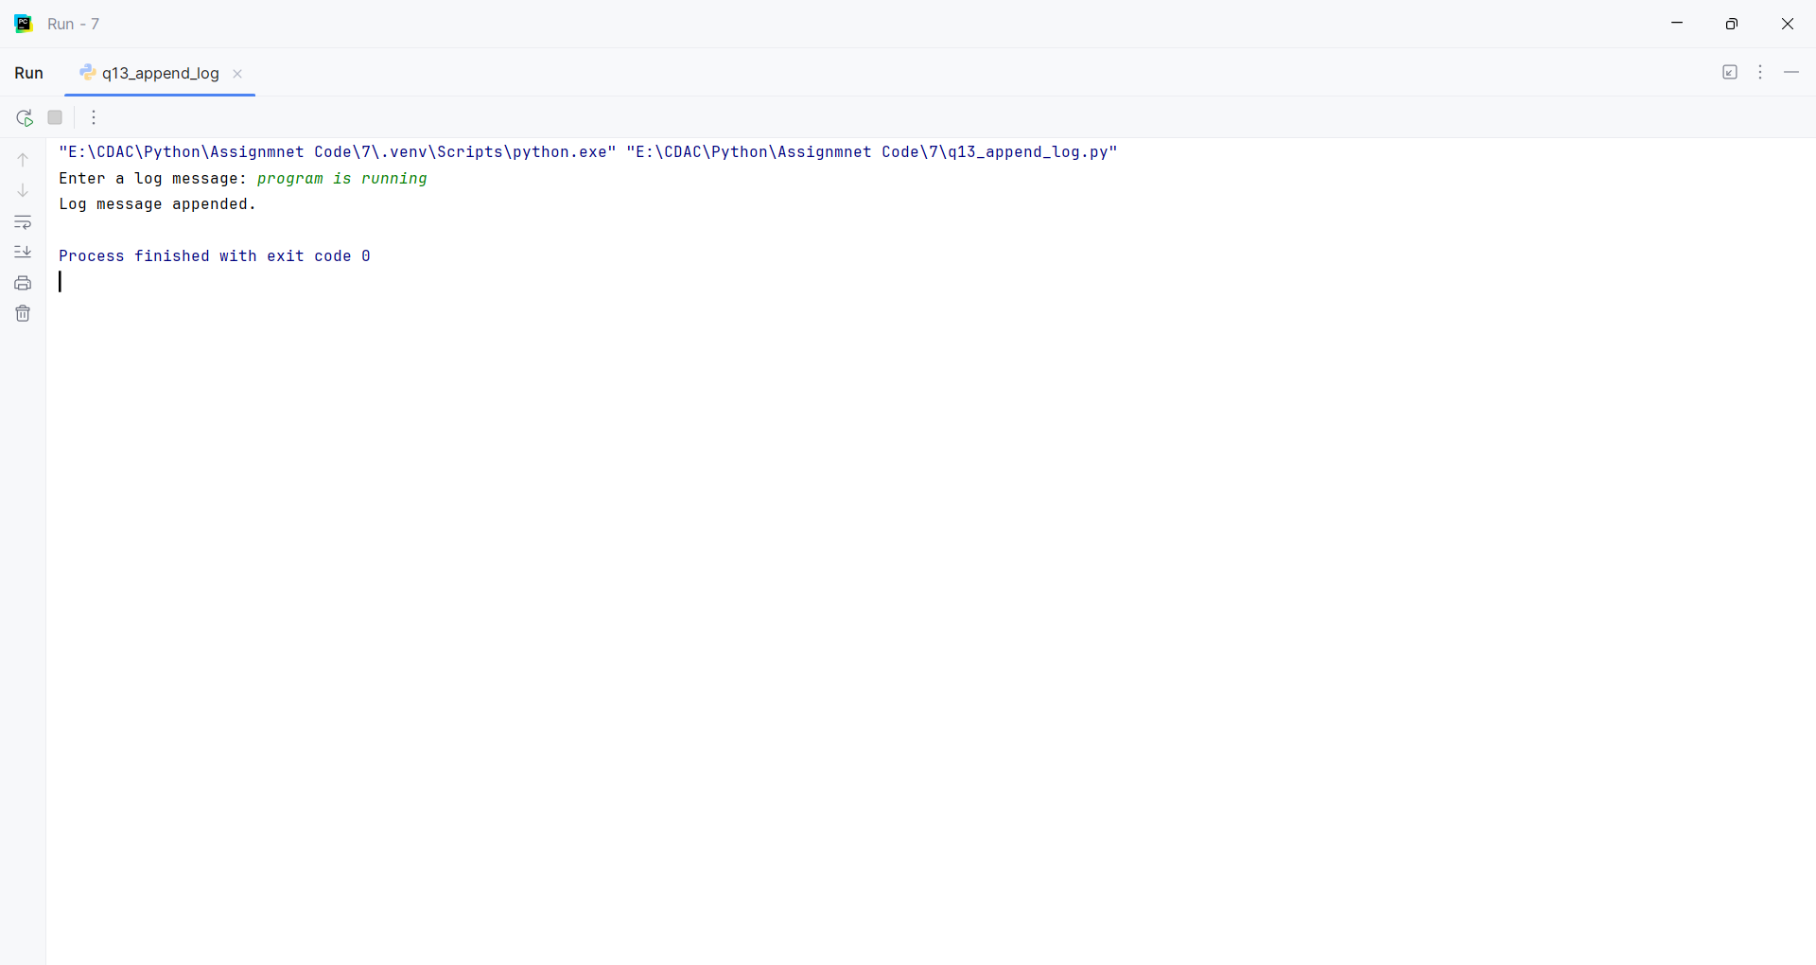
Question:
Write a Simple CSV File:
Write a Python script that takes a list of lists, where each inner list represents a row of data (e.g., [['Name', 'Age'], ['Alice', 30], ['John', 25]]).
The script should write this data to a new CSV file named people.csv.
Use the csv module for this task.
Program
import csv
def write_csv(data):
with open("people.csv", "w", newline="") as file:
writer = csv.writer(file)
writer.writerows(data)
name = input("Enter name: ")
age = input("Enter age: ")
data = [
["Name", "Age"],
["Pratik", 22],
[name, age]
]
write_csv(data)
print("CSV file created successfully.")

Input and Output
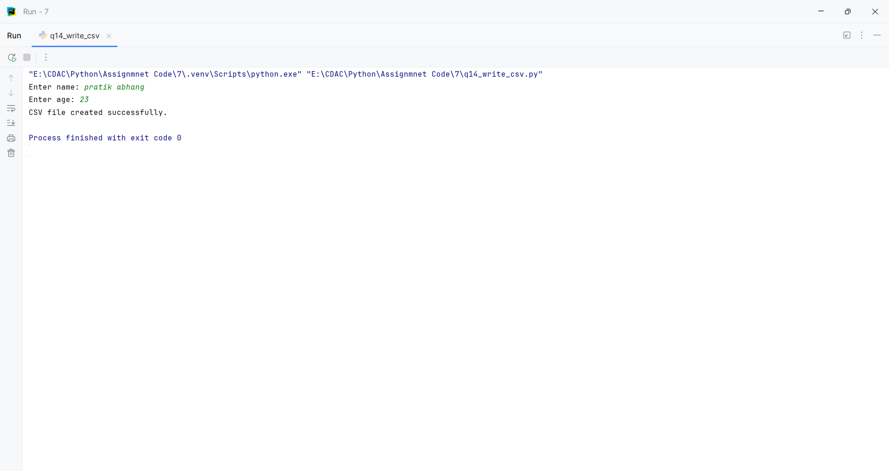

Assignment 8
PNR: 260740150018
Name: PRATIK SUNIL ABHANG
Question:
Q1.
Write a Python program that accepts a sentence from the user and performs the following:
1. Count the number of vowels and consonants.
2. Count the number of digits and special characters.
3. Find the longest word in the sentence.
4. Display all words having more than 5 characters.
5. Check whether the sentence is a palindrome after removing spaces and converting it to lowercase.
Program
def analyze_sentence(text):
vowels = consonants = digits = special = 0
for ch in text:
if ch.isalpha():
if ch.lower() in "aeiou": vowels += 1
else: consonants += 1
elif ch.isdigit(): digits += 1
elif not ch.isspace(): special += 1
words = text.split()
longest = max(words, key=len) if words else ""
long_words = [word for word in words if len(word) > 5]
clean = "".join(text.lower().split())
return vowels, consonants, digits, special, longest, long_words, clean == clean[::-1]
def main():
default = "Madam 123! programming"
text = input(f"Enter a sentence: ").strip()
v, c, d, s, longest, long_words, palindrome = analyze_sentence(text)
print("Vowels:", v, "Consonants:", c)
print("Digits:", d, "Special characters:", s)
print("Longest word:", longest)
print("Words longer than 5:", long_words)
print("Palindrome:", palindrome)
main()

Input and Output
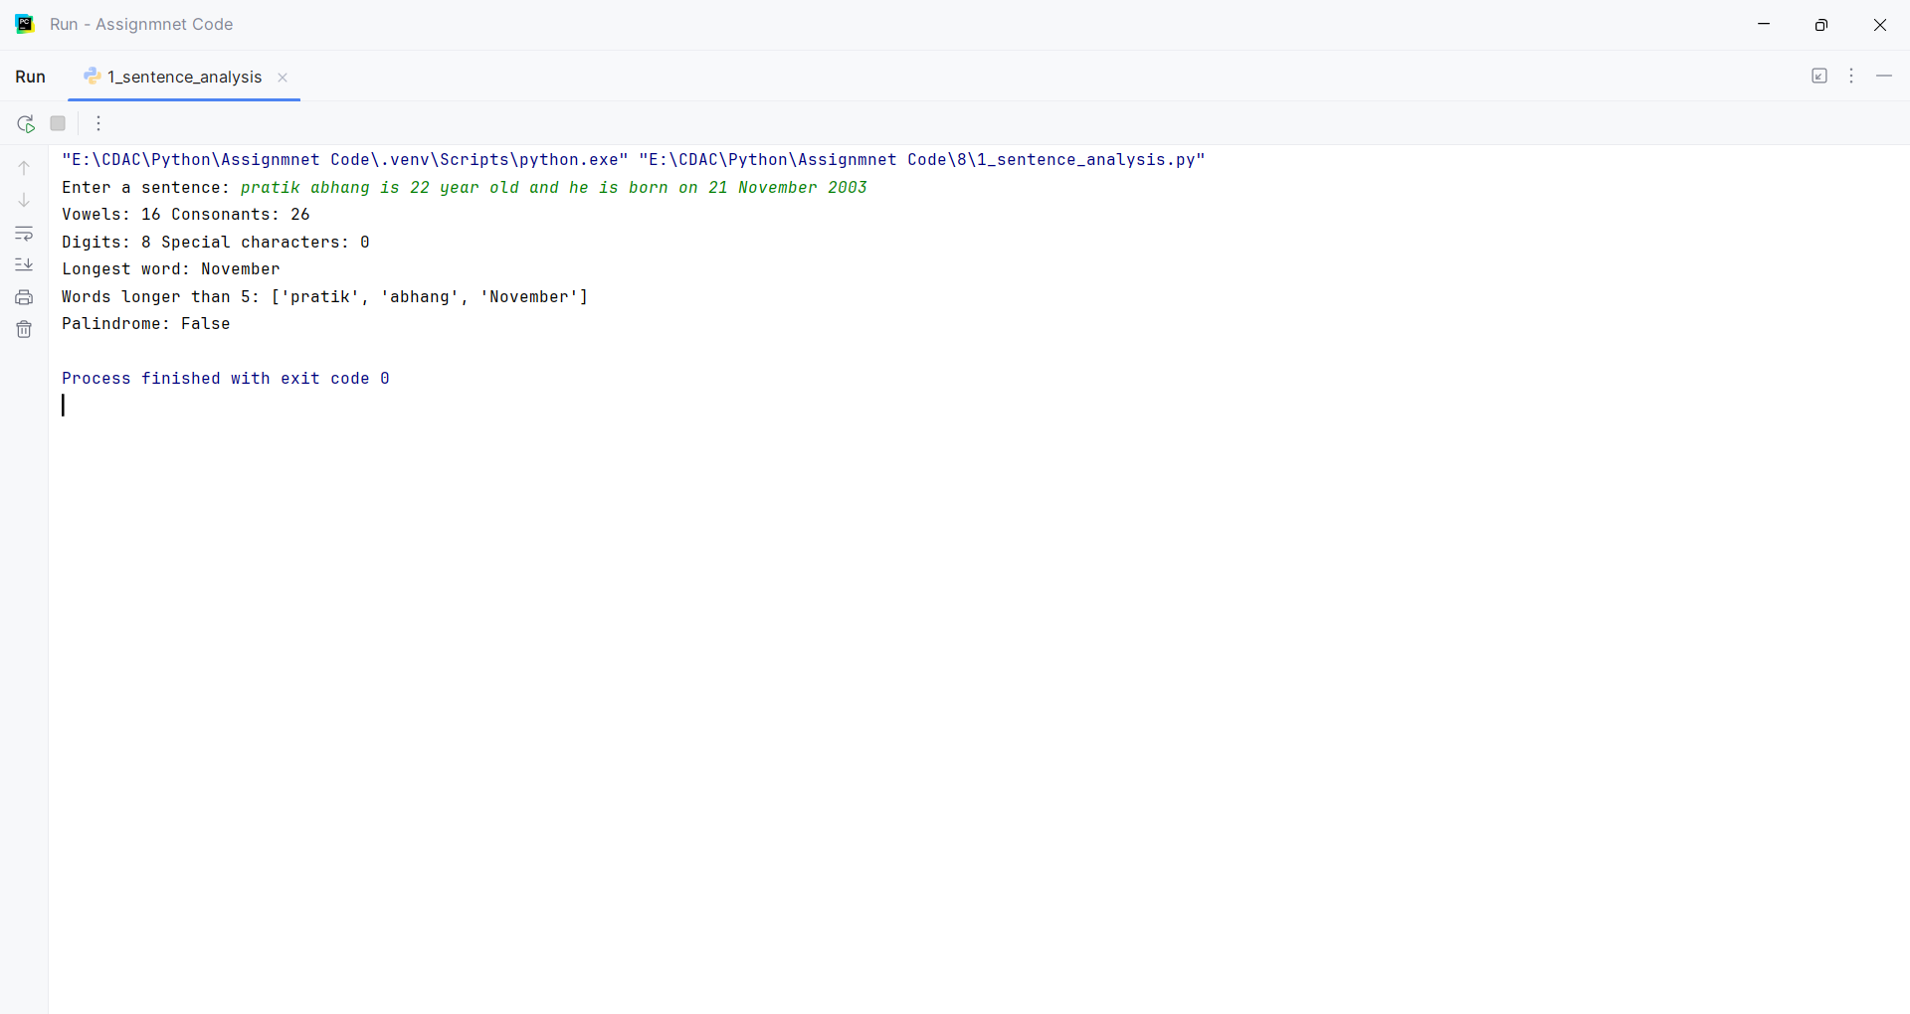
Question:
Q2.
Write a Python program to accept marks of n students into a list.
Perform the following operations:
1. Display all marks.
2. Find the highest and lowest marks without using max() or min().
3. Calculate the average marks.
4. Display students who scored above the average.
5. Count the number of students in each category:
o 75 and above – Distinction
o 60–74 – First Class
o 50–59 – Second Class
o Below 50 – Fail
6. Display the list in reverse order using a loop.
Program
def marks_report(marks):
high = low = marks[0]
for mark in marks:
if mark > high:
high = mark
if mark < low:
low = mark
average = sum(marks) / len(marks)
above = [mark for mark in marks if mark > average]
groups = {
"Distinction": 0,
"First Class": 0,
"Second Class": 0,
"Fail": 0
}
for mark in marks:
if mark >= 75:
groups["Distinction"] += 1
elif mark >= 60:
groups["First Class"] += 1
elif mark >= 50:
groups["Second Class"] += 1
else:
groups["Fail"] += 1
return high, low, average, above, groups
def main():
marks = [float(x) for x in input("Enter marks separated by spaces: ").split()]
high, low, average, above, groups = marks_report(marks)
print("All marks:", marks)
print("Highest:", high, "Lowest:", low, "Average:", round(average, 2))
print("Above average:", above)
print("Categories:", groups)
print("Reverse:", end=" ")
for i in range(len(marks) - 1, -1, -1):
print(marks[i], end=" ")
print()72
main()

Input and Output
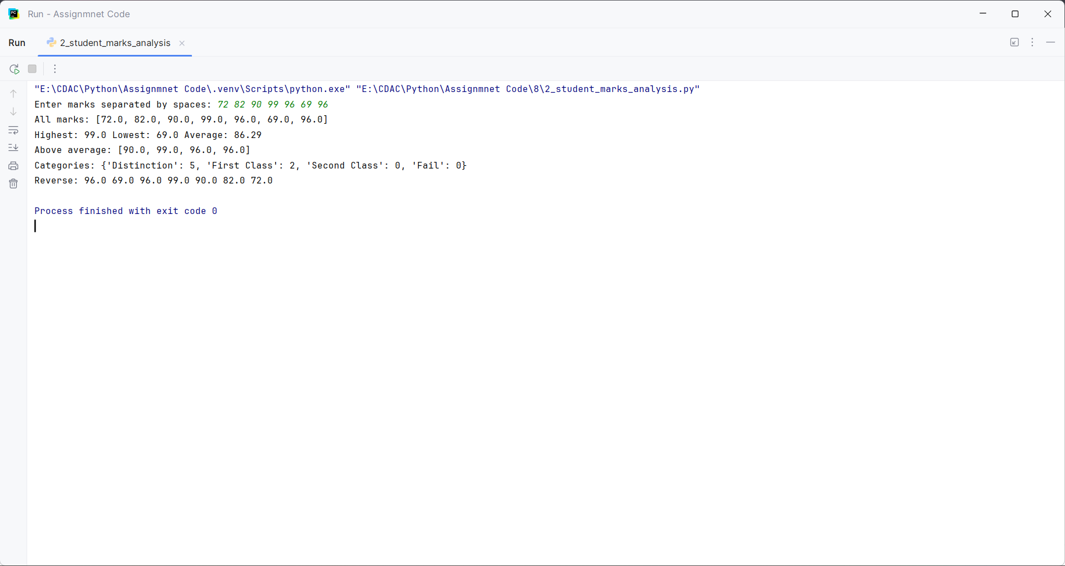
Question:
Q3.
Create a tuple containing employee records in the form:
(employee_id, employee_name, salary)
Write a program to:
1. Display all employees.
2. Find the employee receiving the highest salary.
3. Calculate the average salary.
4. Display employees whose salary is greater than the average.
5. Count employees based on salary categories:
o Below 30,000
o 30,000–60,000
o Above 60,000
6. Search for an employee by employee ID.
Program
def employee_report(employees):
print("All employees:")
for employee in employees:
print(employee)
highest = employees[0]
total = 0
for employee in employees:
total += employee[2]
if employee[2] > highest[2]:
highest = employee
average = total / len(employees)
print("Employee receiving highest salary:", highest)
print("Average salary:", average)
print("Employees whose salary is greater than average:")
for employee in employees:
if employee[2] > average:
print(employee)
below_30000 = 0
between_30000_60000 = 0
above_60000 = 0
for employee in employees:
if employee[2] < 30000:
below_30000 += 1
elif employee[2] <= 60000:
between_30000_60000 += 1
else:
above_60000 += 1
print("Below 30,000:", below_30000)
print("30,000 to 60,000:", between_30000_60000)
print("Above 60,000:", above_60000)
def search_employee(employees):
employee_id = int(input("Enter employee ID to search: "))
for employee in employees:
if employee[0] == employee_id:
print("Employee found:", employee)
return
print("Employee not found")
def main():
n = int(input("Enter number of employees: "))
employee_list = []
for i in range(n):
employee_id = int(input("Enter employee ID: "))
employee_name = input("Enter employee name: ")
salary = float(input("Enter salary: "))
employee_list.append((employee_id, employee_name, salary))
employees = tuple(employee_list)
employee_report(employees)
search_employee(employees)
main()

Input and Output
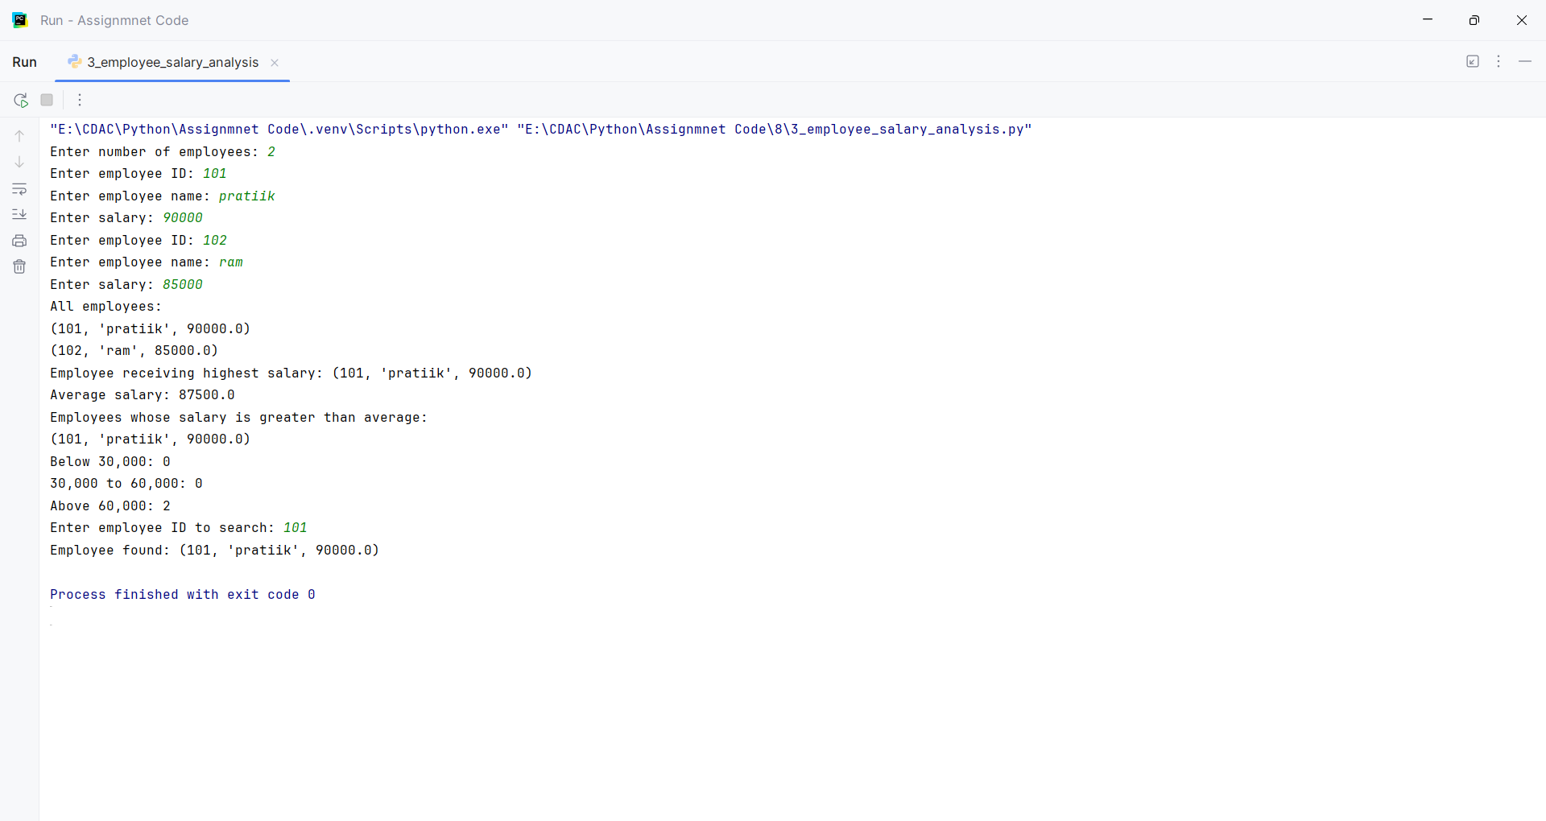
Question:
Q4.
Accept two lists of integers from the user and convert them into sets.
Write a program to:
1. Display unique elements from both lists.
2. Find the union.
3. Find the intersection.
4. Find elements present only in the first list.
5. Find elements present only in the second list.
6. Display common even numbers.
7. Display common odd numbers.
Program
def set_operations(first, second):
a = set(first)
b = set(second)
common = a & b
union = a | b
only_first = a - b
only_second = b - a
even = []
odd = []
for number in common:
if number % 2 == 0:
even.append(number)
else:
odd.append(number)
return a, b, union, common, only_first, only_second, even, odd
def main():
n1 = int(input("Enter number of elements in first list: "))
first = []
for i in range(n1):
number = int(input("Enter element: "))
first.append(number)
n2 = int(input("Enter number of elements in second list: "))
second = []
for i in range(n2):
number = int(input("Enter element: "))
second.append(number)
unique_first, unique_second, union, common, only_first, only_second, even, odd = set_operations(first, second)
print("Unique elements from first list:", unique_first)
print("Unique elements from second list:", unique_second)
print("Union:", union)
print("Intersection:", common)
print("Elements only in first list:", only_first)
print("Elements only in second list:", only_second)
print("Common even numbers:", even)
print("Common odd numbers:", odd)
main()

Input and Output
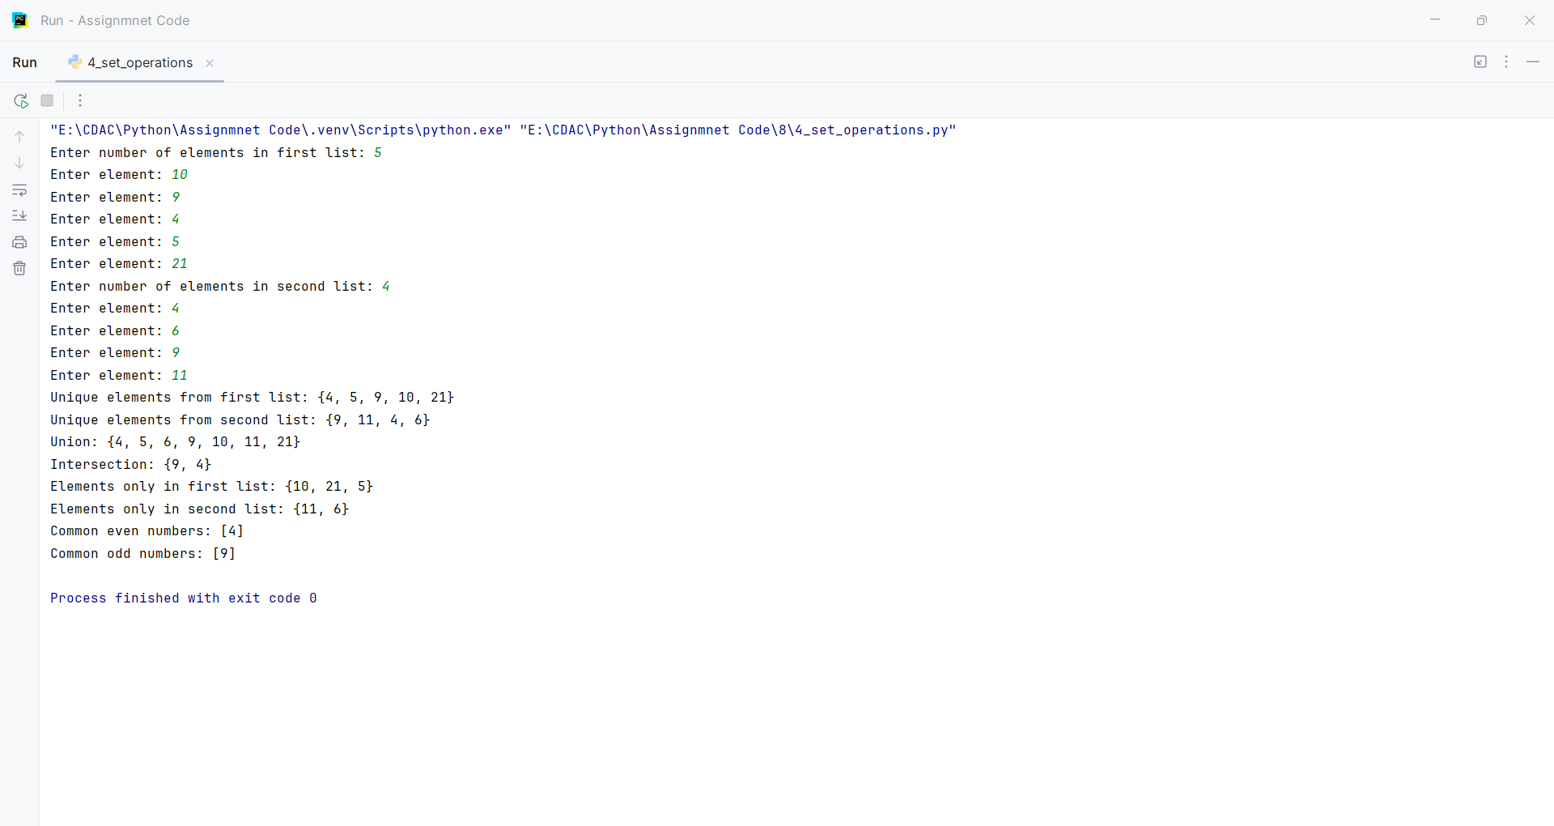
Question:
Q5.
Create a dictionary containing student names and their marks in three subjects.
Example:
students = {
"Amit": [75, 82, 68],
"Neha": [91, 88, 95],
"Rahul": [45, 52, 48]
}
Write a program to:
1. Calculate total and average marks for each student.
2. Assign grades using conditional statements.
3. Display students who have passed in all subjects.
4. Display the student with the highest average.
5. Count the number of students in each grade.
6. Search for a student by name.
Program
def grade(average):
if average >= 75: return "Distinction"
if average >= 60: return "First Class"
if average >= 50: return "Second Class"
return "Fail"

def student_report(students, name):
results, grade_count = {}, {}
best_name, best_average = "", -1
for student, marks in students.items():
total = sum(marks)
average = total / len(marks)
student_grade = grade(average)
results[student] = (total, average, student_grade, all(mark >= 50 for mark in marks))
grade_count[student_grade] = grade_count.get(student_grade, 0) + 1
if average > best_average: best_name, best_average = student, average
return results, grade_count, best_name, results.get(name)

def main():
students = {"Amit": [75, 82, 68], "Neha": [91, 88, 95], "Rahul": [45, 52, 48]}
name = input("Search student [Neha]: ").strip().title() or "Neha"
results, counts, best, found = student_report(students, name)
for student, data in results.items(): print(student, "Total:", data[0], "Average:", round(data[1], 2), "Grade:", data[2])
print("Passed all subjects:", [s for s, d in results.items() if d[3]])
print("Highest average:", best, "Grade counts:", counts)
print("Search result:", found or "Student not found")

main()

Input and Output
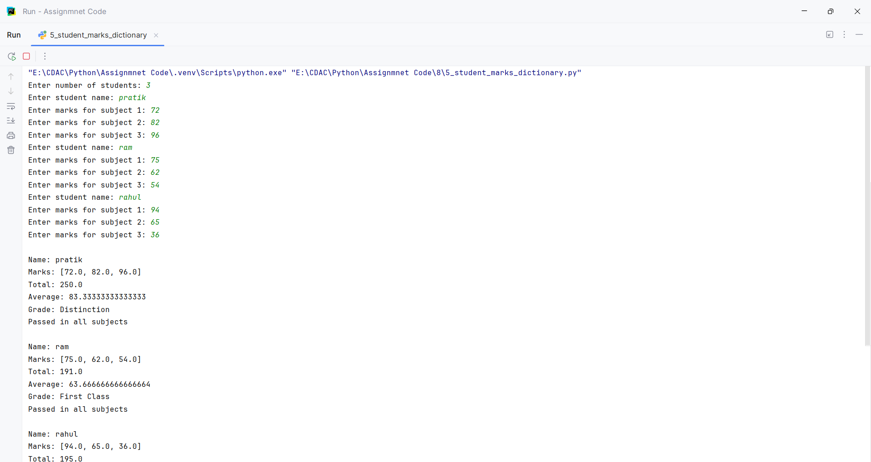
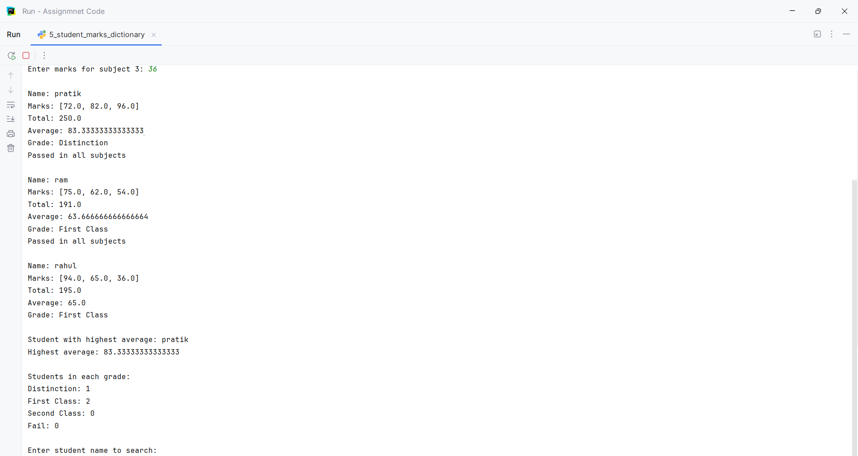
Question:
Q6.
Create a menu-driven Python program using user-defined functions.
The menu should contain:
1. Check Prime Number
2. Check Palindrome
3. Find Factorial
4. Generate Fibonacci Series
5. Exit
Create a separate function for each operation.
Program
def check_prime():
number = int(input("Enter a number: "))
if number < 2:
print("Not a Prime Number")
else:
for i in range(2, int(number ** 0.5) + 1):
if number % i == 0:
print("Not a Prime Number")
return
print("Prime Number")
def check_palindrome():
text = input("Enter a string: ")
if text == text[::-1]:
print("Palindrome")
else:
print("Not a Palindrome")
def find_factorial():
number = int(input("Enter a number: "))
if number < 0:
print("Factorial is not defined for negative numbers")
else:
factorial = 1
for i in range(1, number + 1):
factorial *= i
print("Factorial:", factorial)
def generate_fibonacci():
n = int(input("Enter number of terms: "))
first = 0
second = 1
print("Fibonacci Series:")
for i in range(n):
print(first, end=" ")
first, second = second, first + second
print()
def main():
while True:
print("\n1. Check Prime Number")
print("2. Check Palindrome")
print("3. Find Factorial")
print("4. Generate Fibonacci Series")
print("5. Exit")
choice = input("Enter your choice: ")
if choice == "1":
check_prime()
elif choice == "2":
check_palindrome()
elif choice == "3":
find_factorial()
elif choice == "4":
generate_fibonacci()
elif choice == "5":
print("Program Ended")
break
else:
print("Invalid Choice")
main()

Input and Output
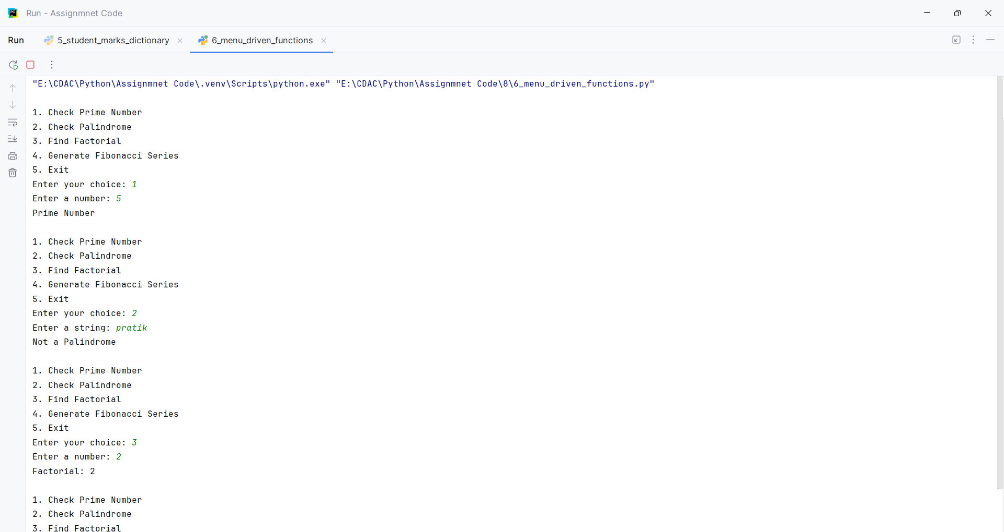
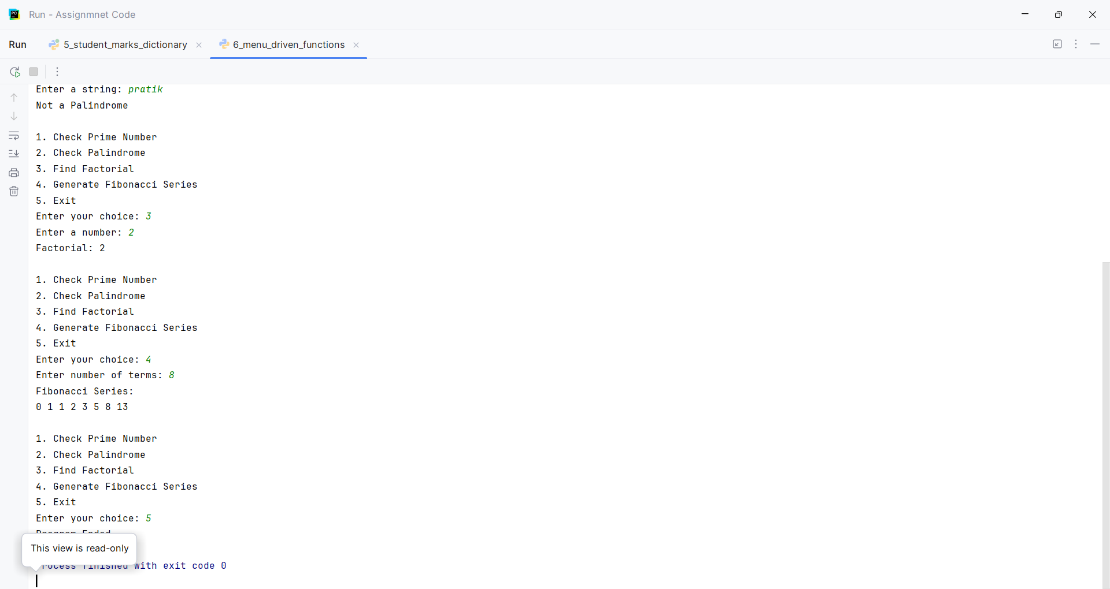
Question:
Q7.
Create a class BankAccount with the following attributes:
account_number
customer_name
balance
Create methods:
deposit()
withdraw()
check_balance()
display_details()
Apply the following conditions:
• Deposit amount must be greater than zero.
• Withdrawal amount must not exceed the balance.
• Display an appropriate message for insufficient balance.
• Allow multiple transactions using a loop.
• Provide a menu:
1. Deposit
2. Withdraw
3. Check Balance
4. Account Details
5. Exit
Program
class BankAccount:
def __init__(self, account_number, customer_name, balance):
self.account_number = account_number
self.customer_name = customer_name
self.balance = balance
def deposit(self):
amount = float(input("Enter deposit amount: "))
if amount > 0:
self.balance += amount
print("Deposit successful")
else:
print("Deposit amount must be greater than zero")
def withdraw(self):
amount = float(input("Enter withdrawal amount: "))
if amount <= 0:
print("Withdrawal amount must be greater than zero")
elif amount > self.balance:
print("Insufficient balance")
else:
self.balance -= amount
print("Withdrawal successful")
def check_balance(self):
print("Current balance:", self.balance)
def display_details(self):
print("Account Number:", self.account_number)
print("Customer Name:", self.customer_name)
print("Balance:", self.balance)
def main():
account_number = input("Enter account number: ")
customer_name = input("Enter customer name: ")
balance = float(input("Enter opening balance: "))
account = BankAccount(account_number, customer_name, balance)
while True:
print("\n1. Deposit")
print("2. Withdraw")
print("3. Check Balance")
print("4. Account Details")
print("5. Exit")
choice = input("Enter your choice: ")
if choice == "1":
account.deposit()
elif choice == "2":
account.withdraw()
elif choice == "3":
account.check_balance()
elif choice == "4":
account.display_details()
elif choice == "5":
print("Thank you")
break
else:
print("Invalid choice")
main()

Input and Output
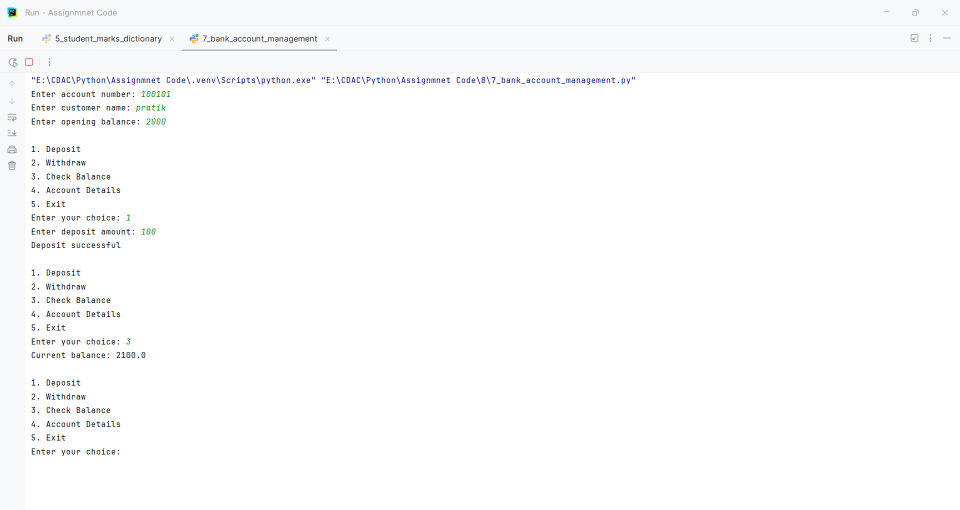
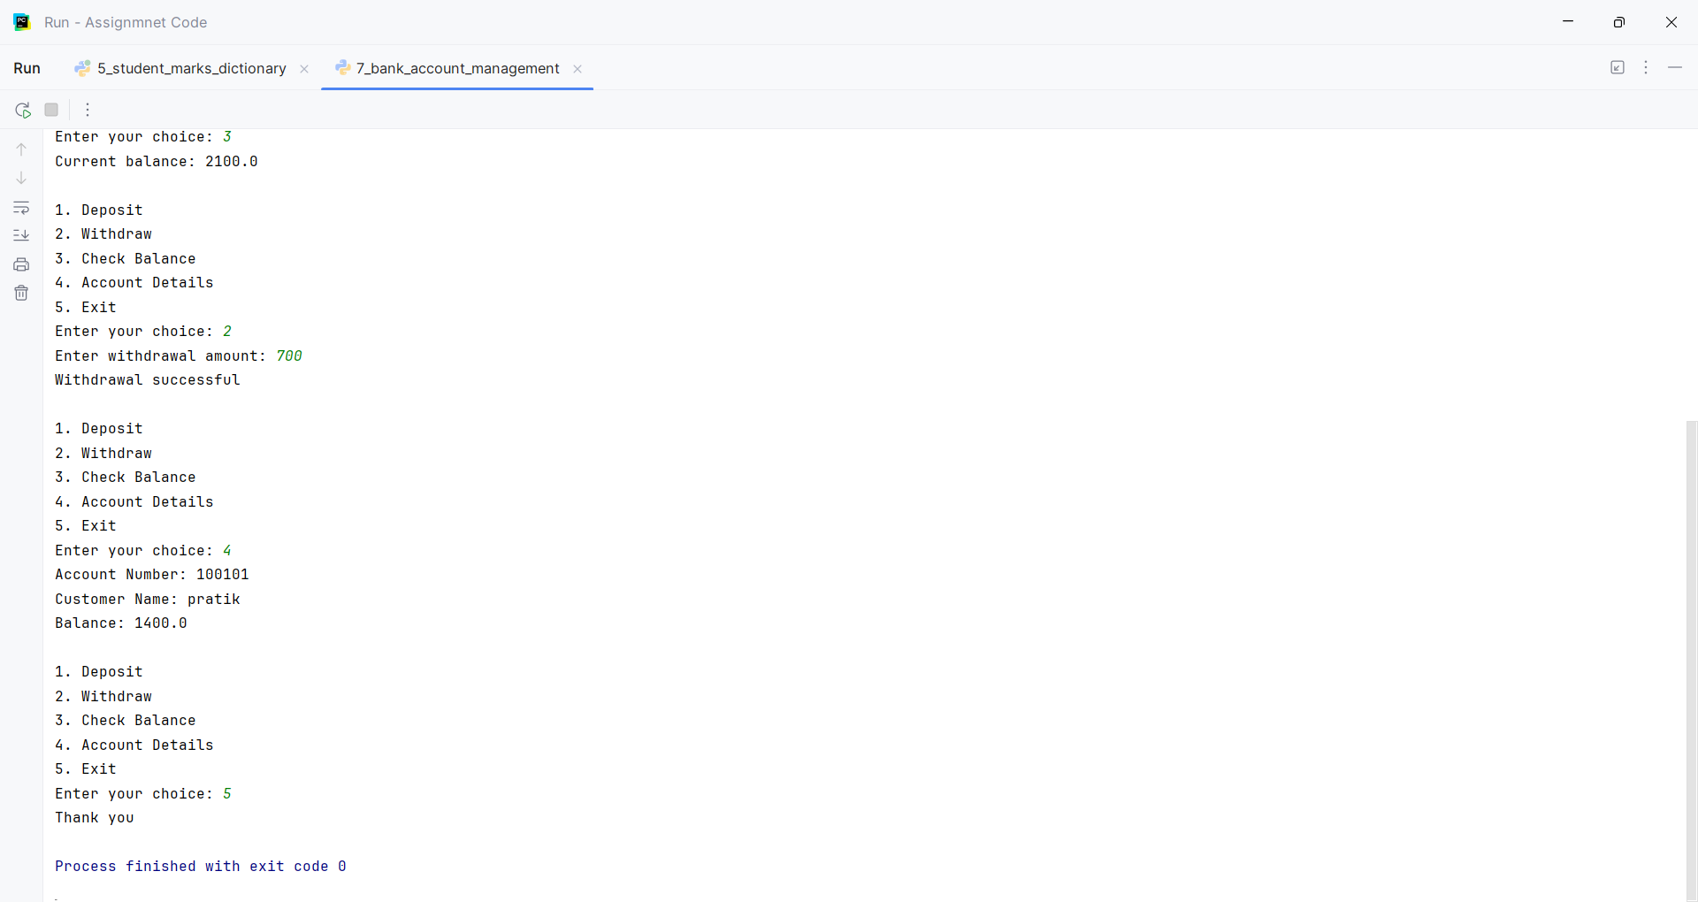
Question:
Q8.
Write a Python program using the re module to validate user input.
Validate:
1. Mobile number
2. Email address
3. Password
4. PIN code
5. Username
Use regular expressions and conditional statements to display whether each input is Valid or Invalid.
For the password, enforce:
• At least 8 characters
• At least one uppercase letter
• At least one lowercase letter
• At least one digit
• At least one special character
Program
import re
def validate_mobile(mobile):
pattern = r"^[6-9]\d{9}$"
if re.fullmatch(pattern, mobile):
return "Valid"
else:
return "Invalid"
def validate_email(email):
pattern = r"^[A-Za-z0-9._%+-]+@[A-Za-z0-9.-]+\.[A-Za-z]{2,}$"
if re.fullmatch(pattern, email):
return "Valid"
else:
return "Invalid"
def validate_password(password):
pattern = r"^(?=.*[A-Z])(?=.*[a-z])(?=.*\d)(?=.*[^A-Za-z0-9]).{8,}$"
if re.fullmatch(pattern, password):
return "Valid"
else:
return "Invalid"
def validate_pin(pin):
pattern = r"^\d{6}$"
if re.fullmatch(pattern, pin):
return "Valid"
else:
return "Invalid"
def validate_username(username):
pattern = r"^[A-Za-z][A-Za-z0-9_]{2,19}$"
if re.fullmatch(pattern, username):
return "Valid"
else:
return "Invalid"
def main():
mobile = input("Enter mobile number: ")
email = input("Enter email address: ")
password = input("Enter password: ")
pin = input("Enter PIN code: ")
username = input("Enter username: ")
print("Mobile number:", validate_mobile(mobile))
print("Email address:", validate_email(email))
print("Password:", validate_password(password))
print("PIN code:", validate_pin(pin))
print("Username:", validate_username(username))
main()

Input and Output
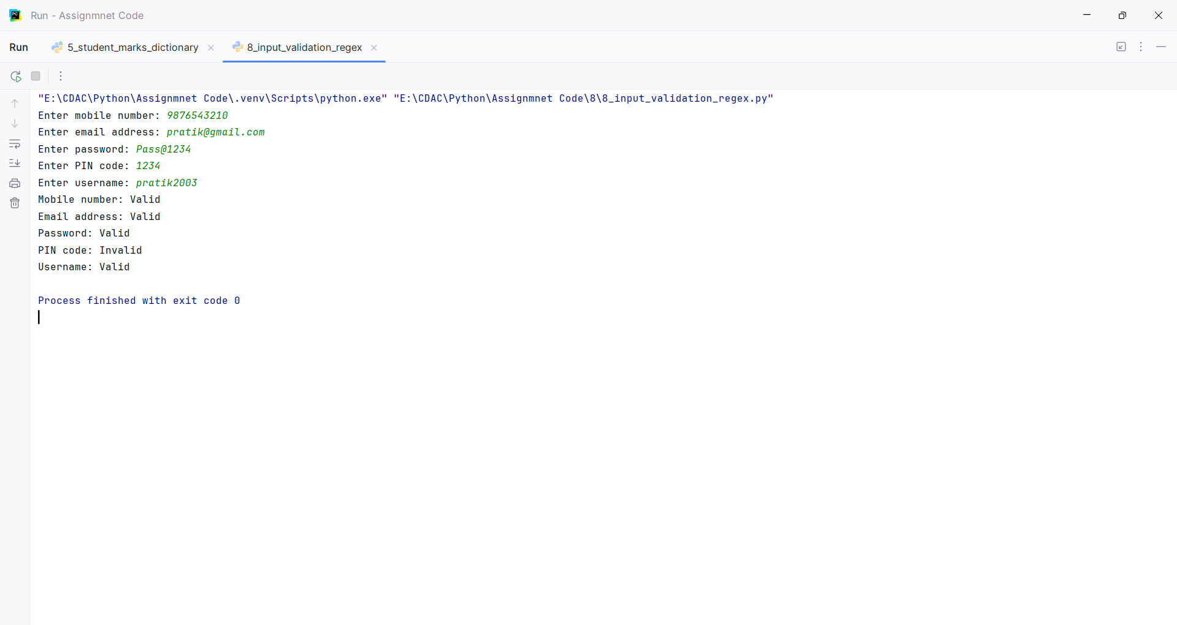

Assignment 9
PNR: 260740150018
Name: PRATIK SUNIL ABHANG
Question:
Write a function apply_discount(price, discount_percentage) where:
• An assert statement checks that discount_percentage is strictly between 0 and 100.
• Another assert statement checks that the final price is never negative or higher than the original price.
• Test your function with a valid discount (e.g., 20%) and an invalid discount (e.g., 120%) to show the traceback.
Program
def apply_discount(price, discount_percentage):
assert 0 < discount_percentage < 100, "Discount percentage must be between 0 and 100"
final_price = price - (price * discount_percentage / 100)
assert 0 <= final_price <= price, "Final price is invalid"
return final_price
print("Valid discount:")
print(apply_discount(1000, 20))
print("\nInvalid discount:")
print(apply_discount(1000, 120))

Input and Output
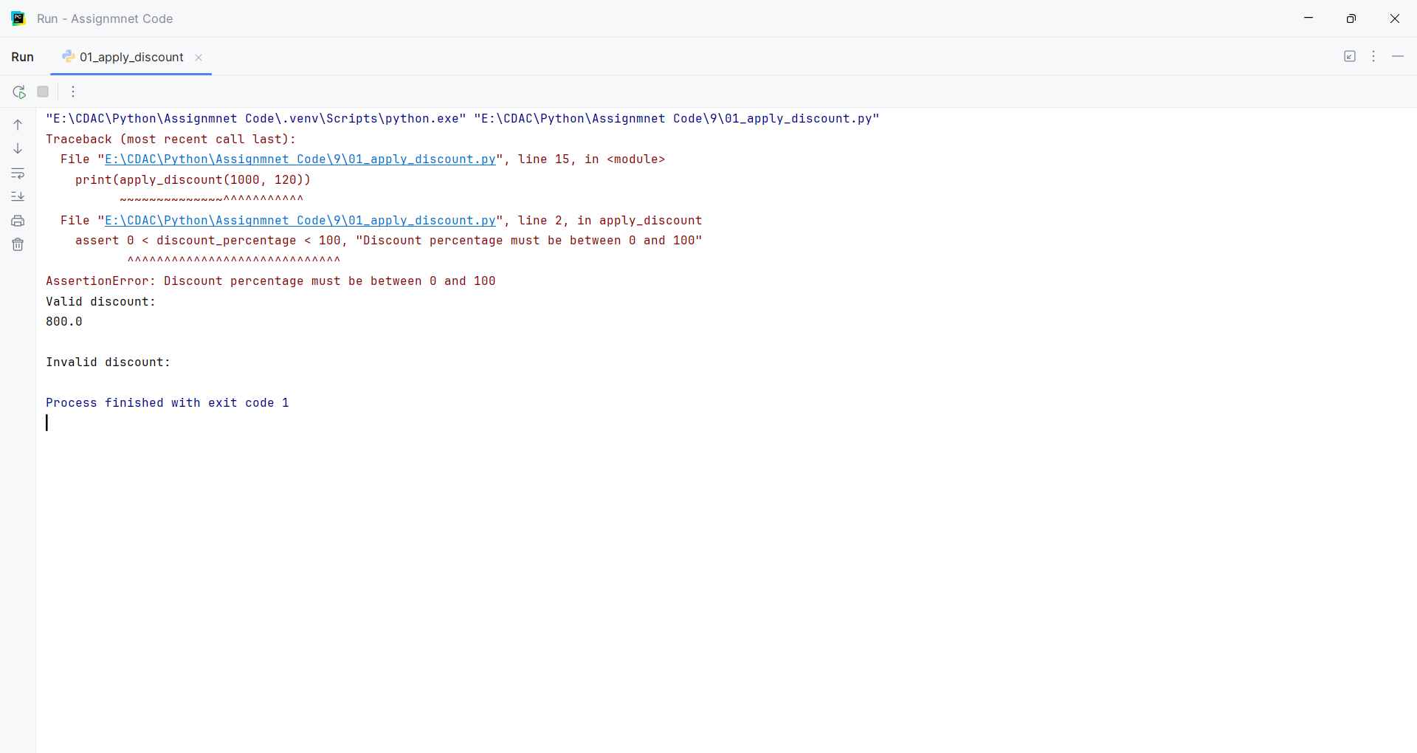
Question:
Create a program that prompts the user to enter two numbers (A and B) and outputs the result of A / B. Wrap the execution inside a try block and implement specific except clauses to handle.
• ValueError: Handled when a user inputs a non-numeric string (e.g., "abc").
• ZeroDivisionError: Handled when B is zero.
Program
try:
A = float(input("Enter number A: "))
B = float(input("Enter number B: "))
result = A / B
print("Result =", result)
except ValueError:
print("Error: Please enter numeric values only.")
except ZeroDivisionError:
print("Error: Cannot divide by zero.")

Input and Output
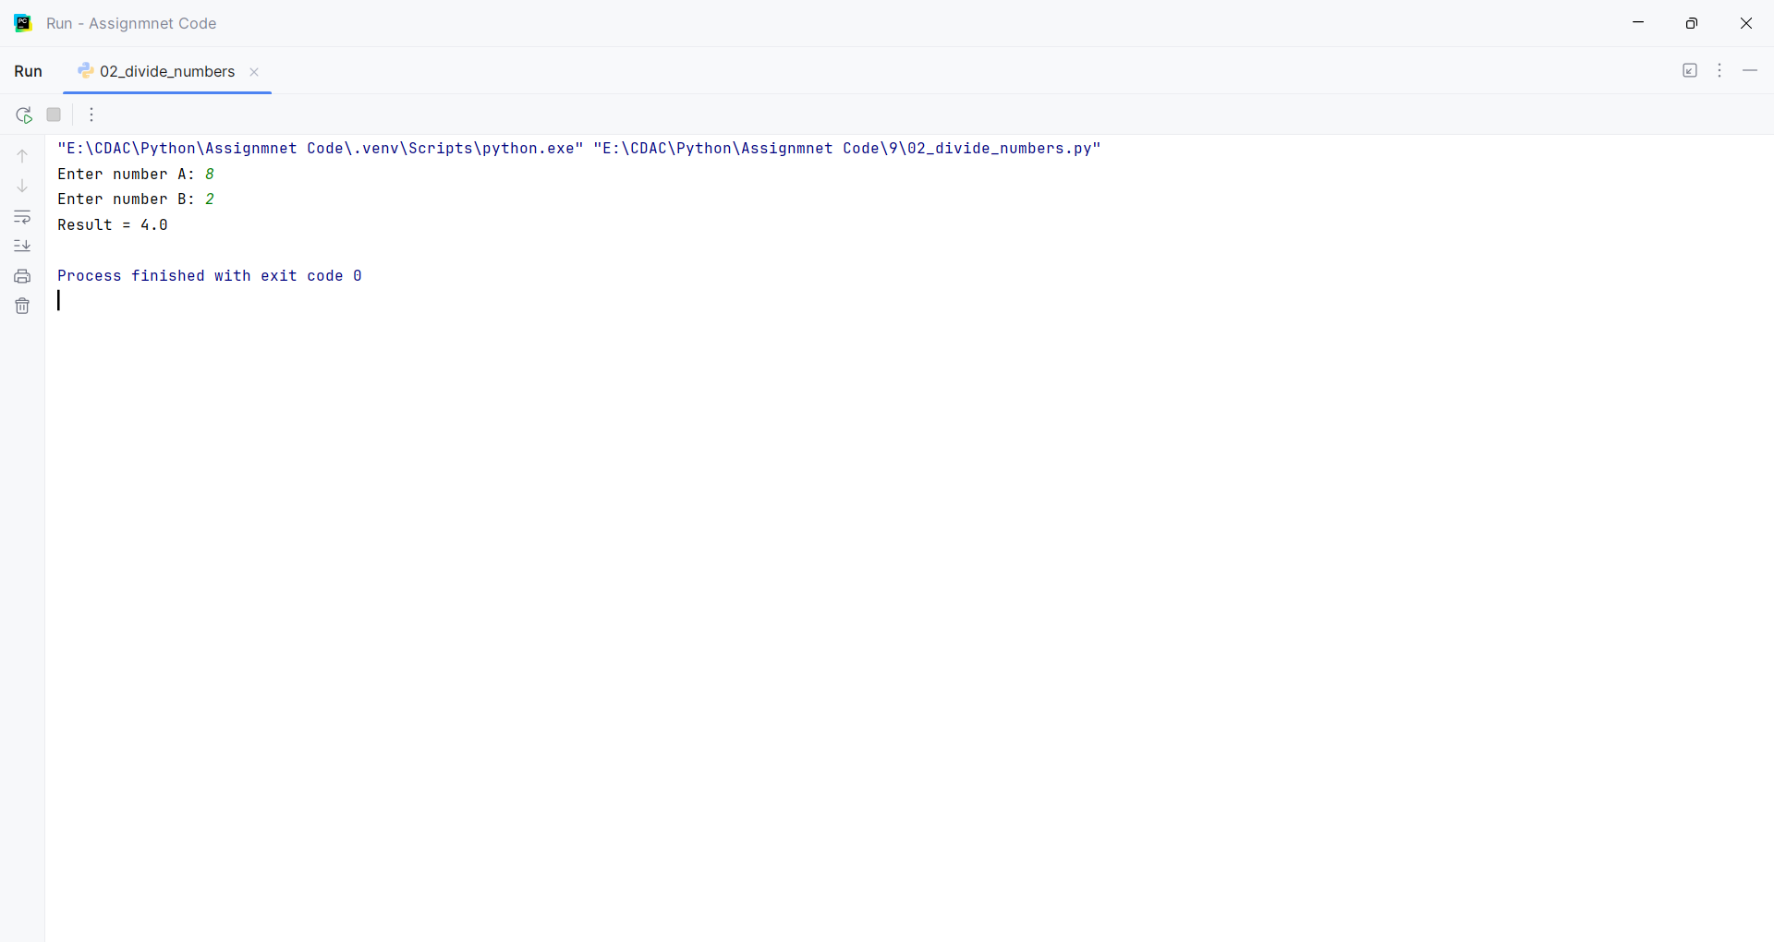
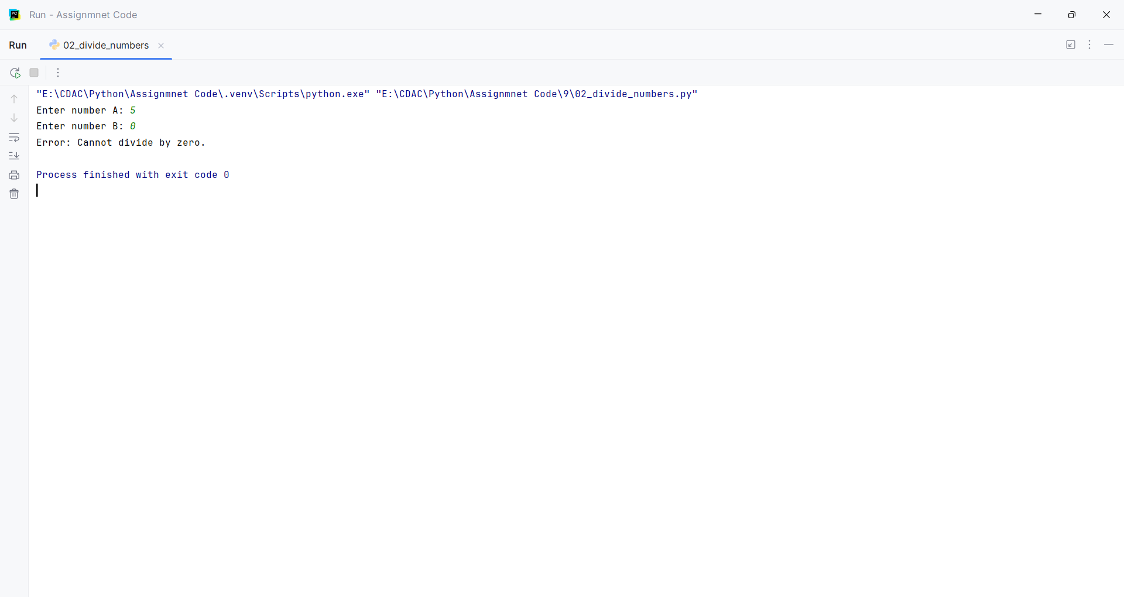
Question:
Write a program that requests a filename from the user and attempts to open it in read-only mode.
• Intercept FileNotFoundError if the file doesn't exist.
• Intercept PermissionError if the user lacks the credentials to open the file
Program
filename = input("Enter the filename: ")
try:
file = open(filename, "r")
print(file.read())
file.close()
except FileNotFoundError:
print("Error: File does not exist.")
except PermissionError:
print("Error: You do not have permission to open this file.")

Input and Output
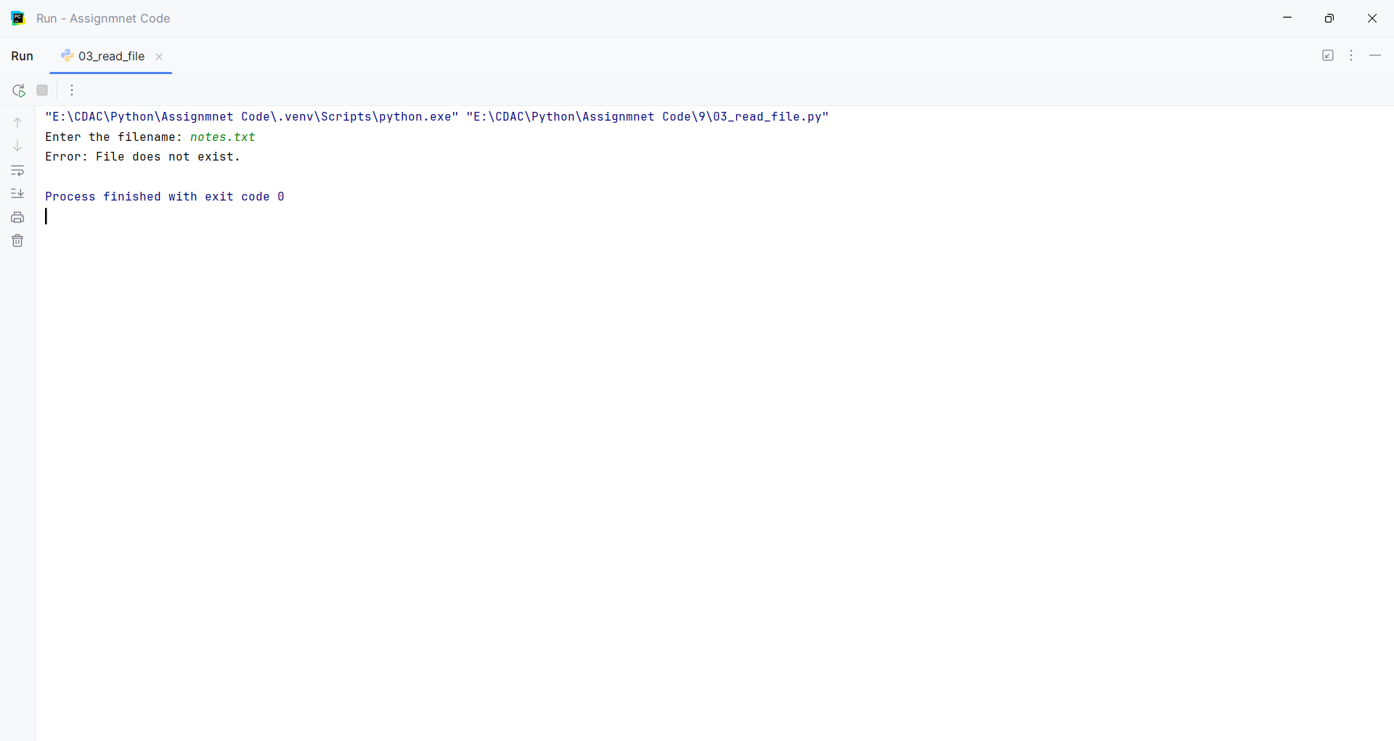
Question:
Create a class named Countdown.
• The constructor __init__(self, start) should accept a starting integer.
• Implement __iter__(self) to return the iterator object itself.
• Implement __next__(self) to return numbers counting down to 0.
• Once it hits 0, it should raise a StopIteration exception to halt the loop.
Program
class Countdown:
def __init__(self, start):
self.start = start
def __iter__(self):
return self
def __next__(self):
if self.start < 0:
raise StopIteration
current = self.start
self.start -= 1
return current
countdown = Countdown(5)
for number in countdown:
print(number)

Input and Output
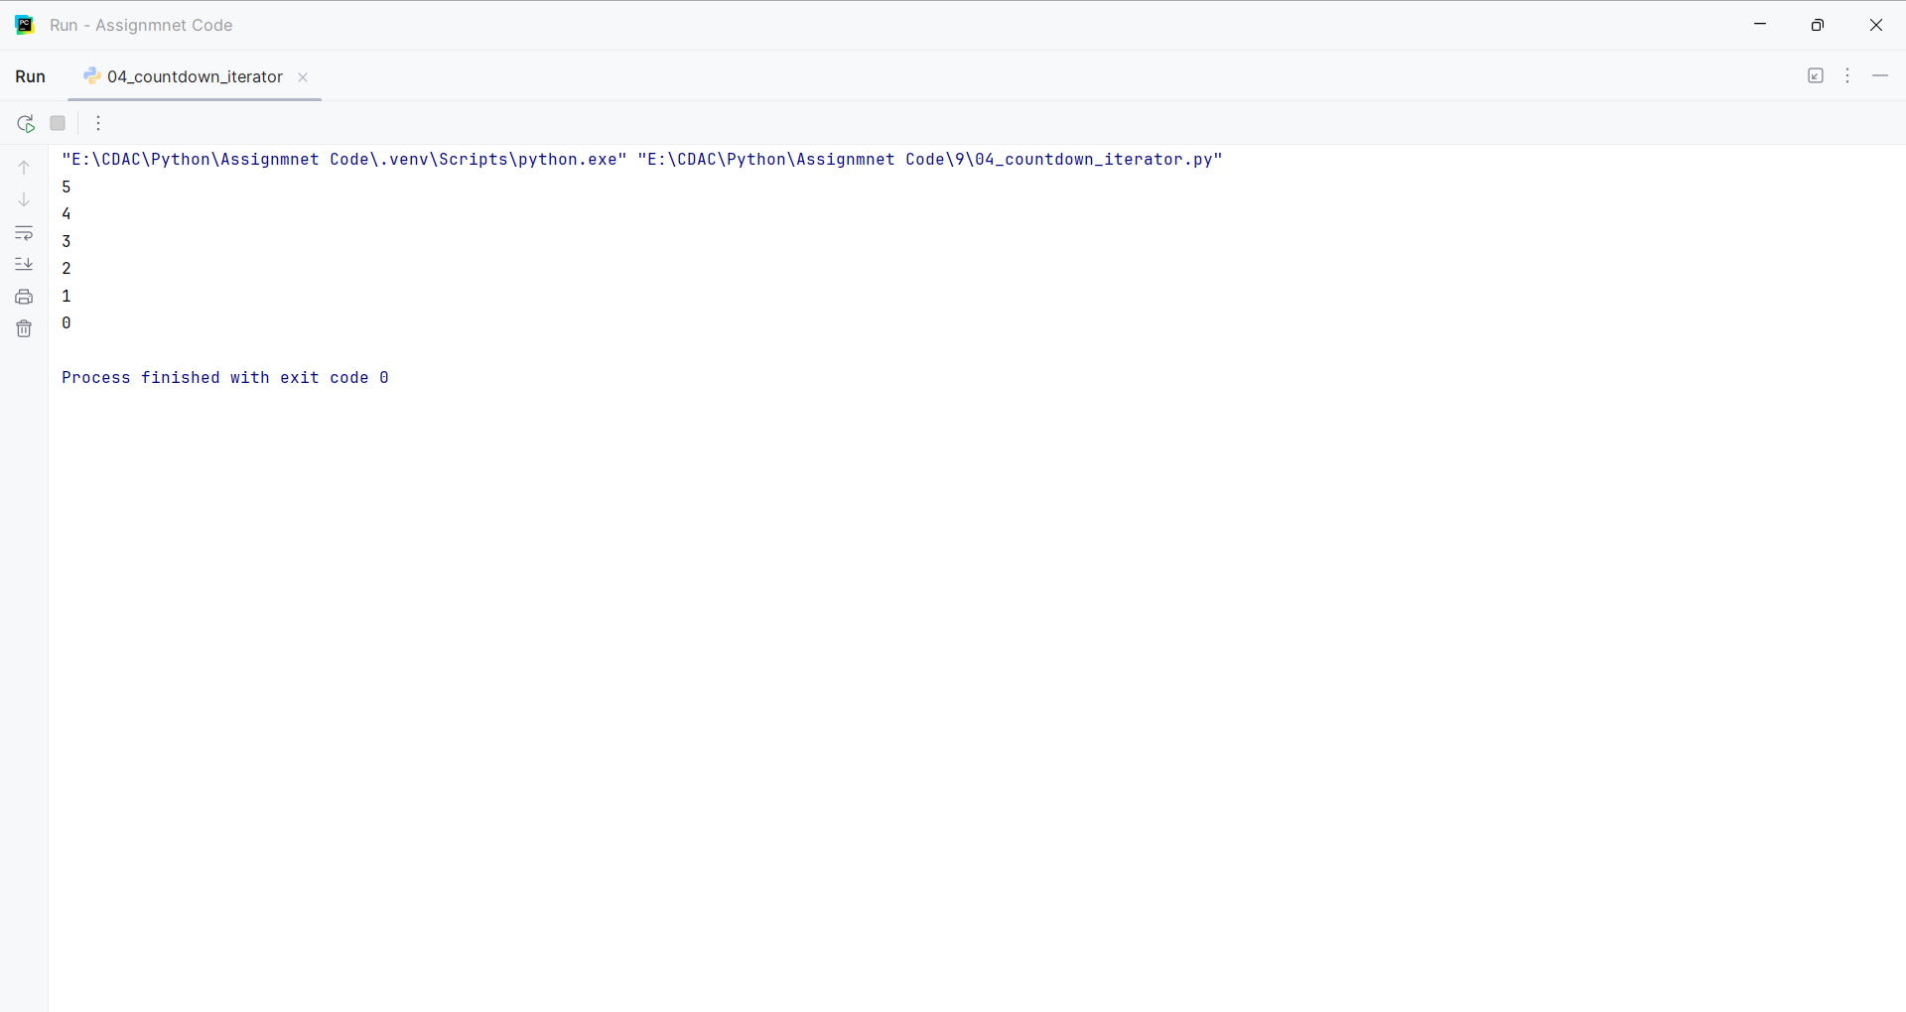
Question:
Write a generator function named fibonacci_gen(limit).
• It should calculate and yield Fibonacci numbers one by one.
• The generator must stop yielding once a number exceeds the specified limit.
Program
def fibonacci_gen(limit):
a = 0
b = 1
while a <= limit:
yield a
a, b = b, a + b
limit = int(input("Enter the limit: "))
for number in fibonacci_gen(limit):
print(number)

Input and Output
